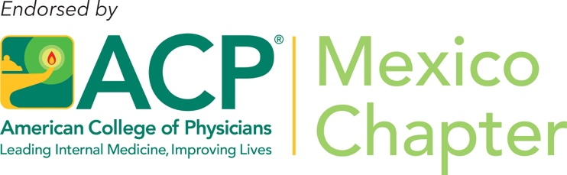

ACP Symposium “Microbiota, más alla de la salud gastrointestinal” at Curso Internacional de Medicina Interna 2019

From July 3 to 6, 2019, the Curso Internacional de Medicina Interna, organized by the Colegio de Medicina Interna de México was held in Monterrey, NL, Mexico, with a total of 1045 attendants and 83 invited lecturers. The meeting was a great success within the Internal Medicine community.

The ACP symposium during the Curso Internacional de Medicina Interna was held on July 5th. Dr. Edith Flores FACP was the chair of the Symposium entitled “Microbiota, más allá de la salud gastrointestinal” (Gut microbiota, beyond gastrointestinal healthcare) with the following lecturers:

Dr. Héctor Maldonado
Lecture: Microbiota y tubo digestivo (Gut micriobiota and digestive tract)

Dr. Guillermo J. Ruiz-Argüelles, MACP
Lecture: Microbiota en enfermedades hematológicas (Gut microbiota in hematological malignancies)

Dr. Martín Herrera, FACP
Lecture: Microbiota en enfermedades cardiovasculares (Gut microbiota in cardiovascular disease)

With a total of 500 attendants, the ACP symposium was a great success. At the end of the symposium, Dr. Guilermo J. Ruiz-Arguelles FACP delivered the “Mexico Chapter Laureate Award” to Dr. Carlos LIJSTAIN, current chair of the Mexican Board of Internal Medicine (Consejo Mexicano de Medicina Interna)
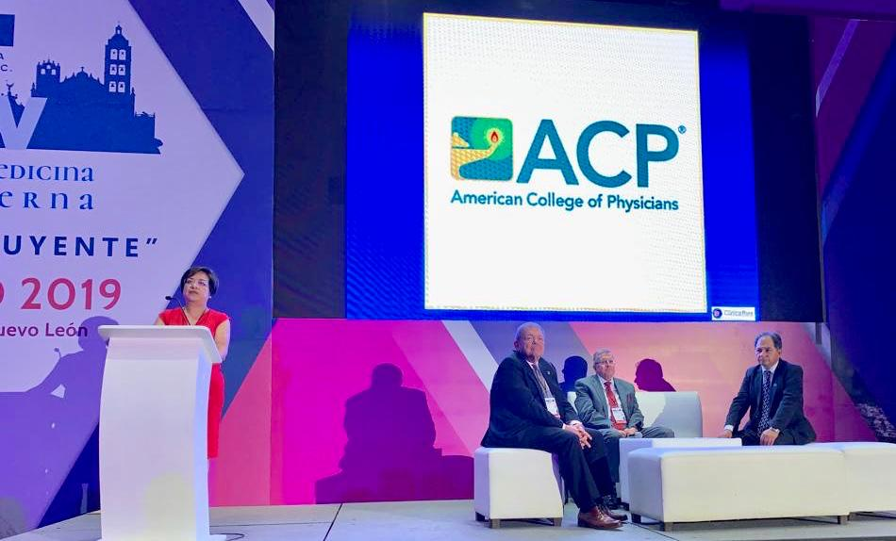
ACP Symposium “Microbiota, más alla de la salud gastrointestinal” (Gut microbiota, beyond gastrointestinal healthcare)

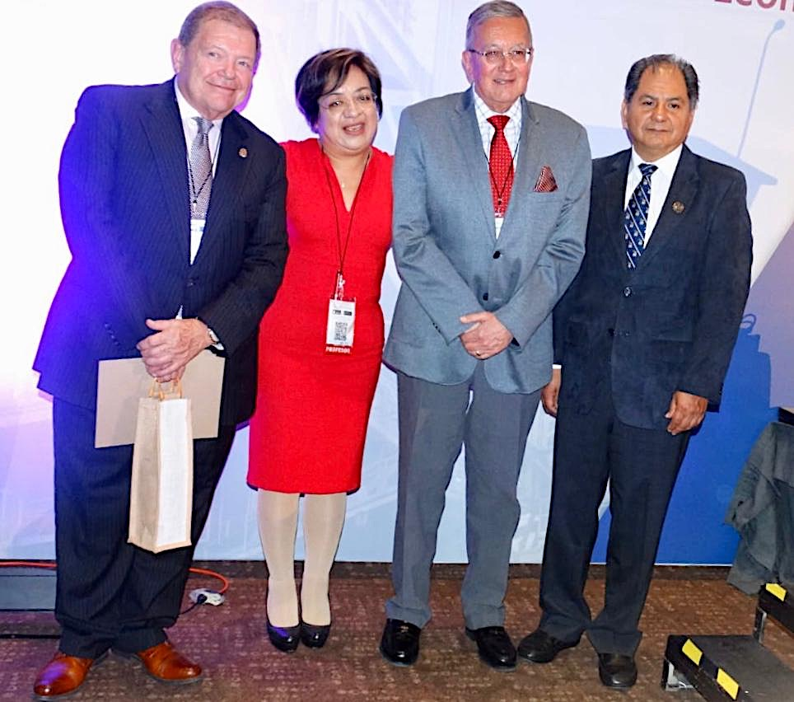

Symposium coordinator Dr. Edith Flores FACP with participant Professors Dr. Héctor Maldonado, Dr. Guillermo J. Ruiz-Argüelles MACP and Dr. Martín Herrera-Cornejo FACP
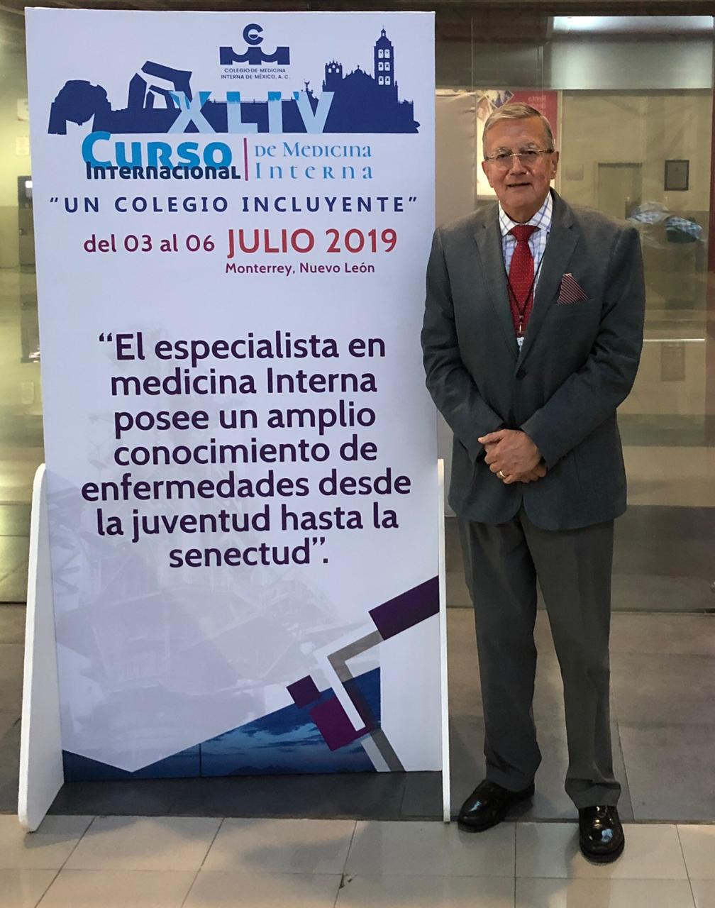

Governor of the ACP Mexico Chapter, Dr. Guillermo J. Ruiz-Argüelles at the Curso Internacional de Medicina Interna 2019

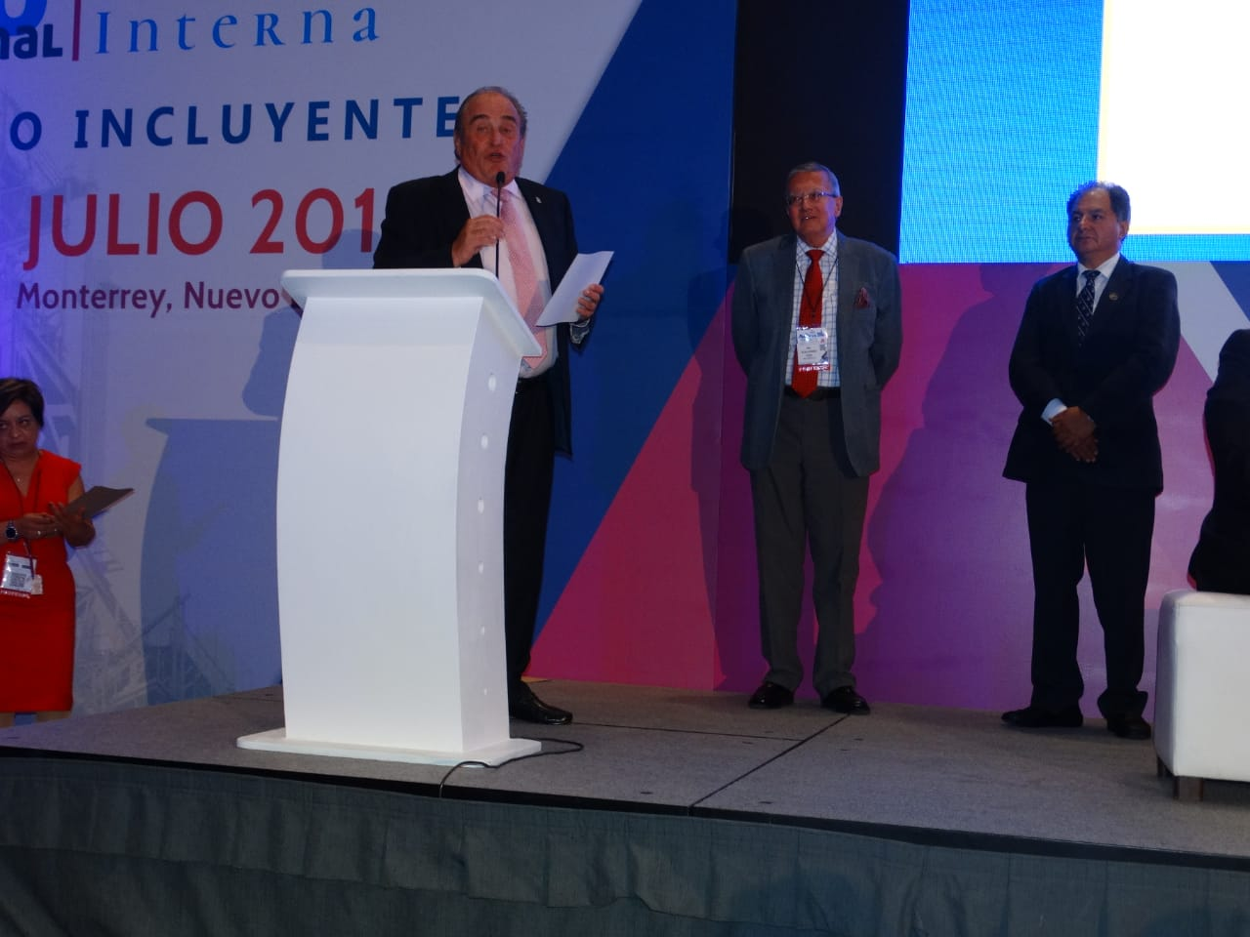
Dr. Carlos LIJSTAIN, current chair of the Mexican Board of Internal Medicine (Consejo Mexicano de Medicina Interna) receiving the “Mexico Chapter Laureate Award”

