This refrigerator used for SPECIMENS only.
ATTENTION
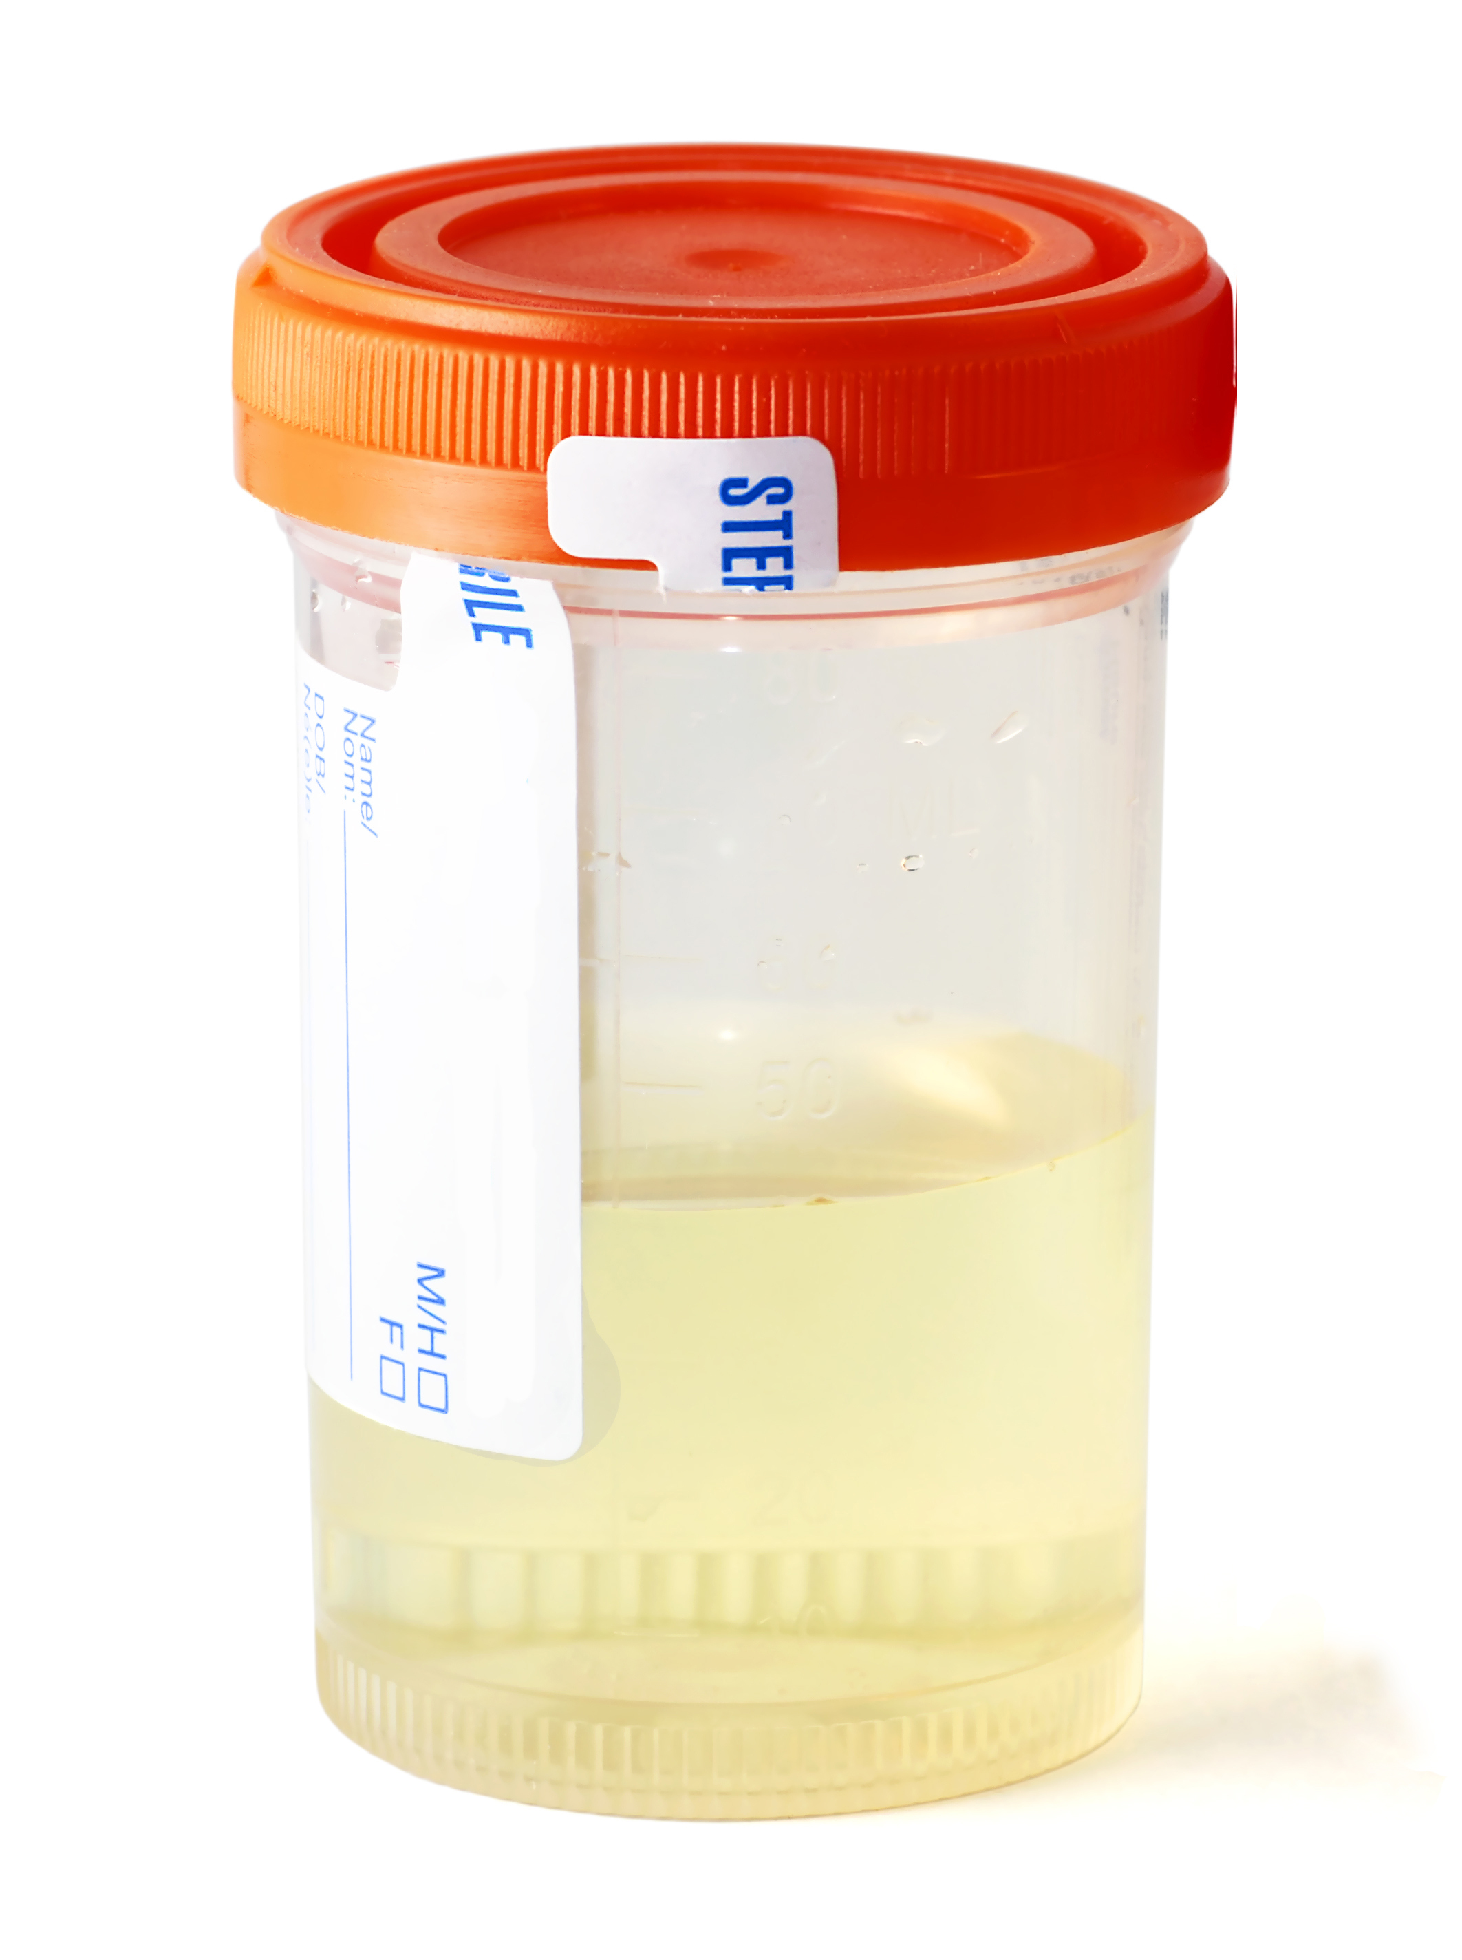
www.acponline.org/practiceforms

