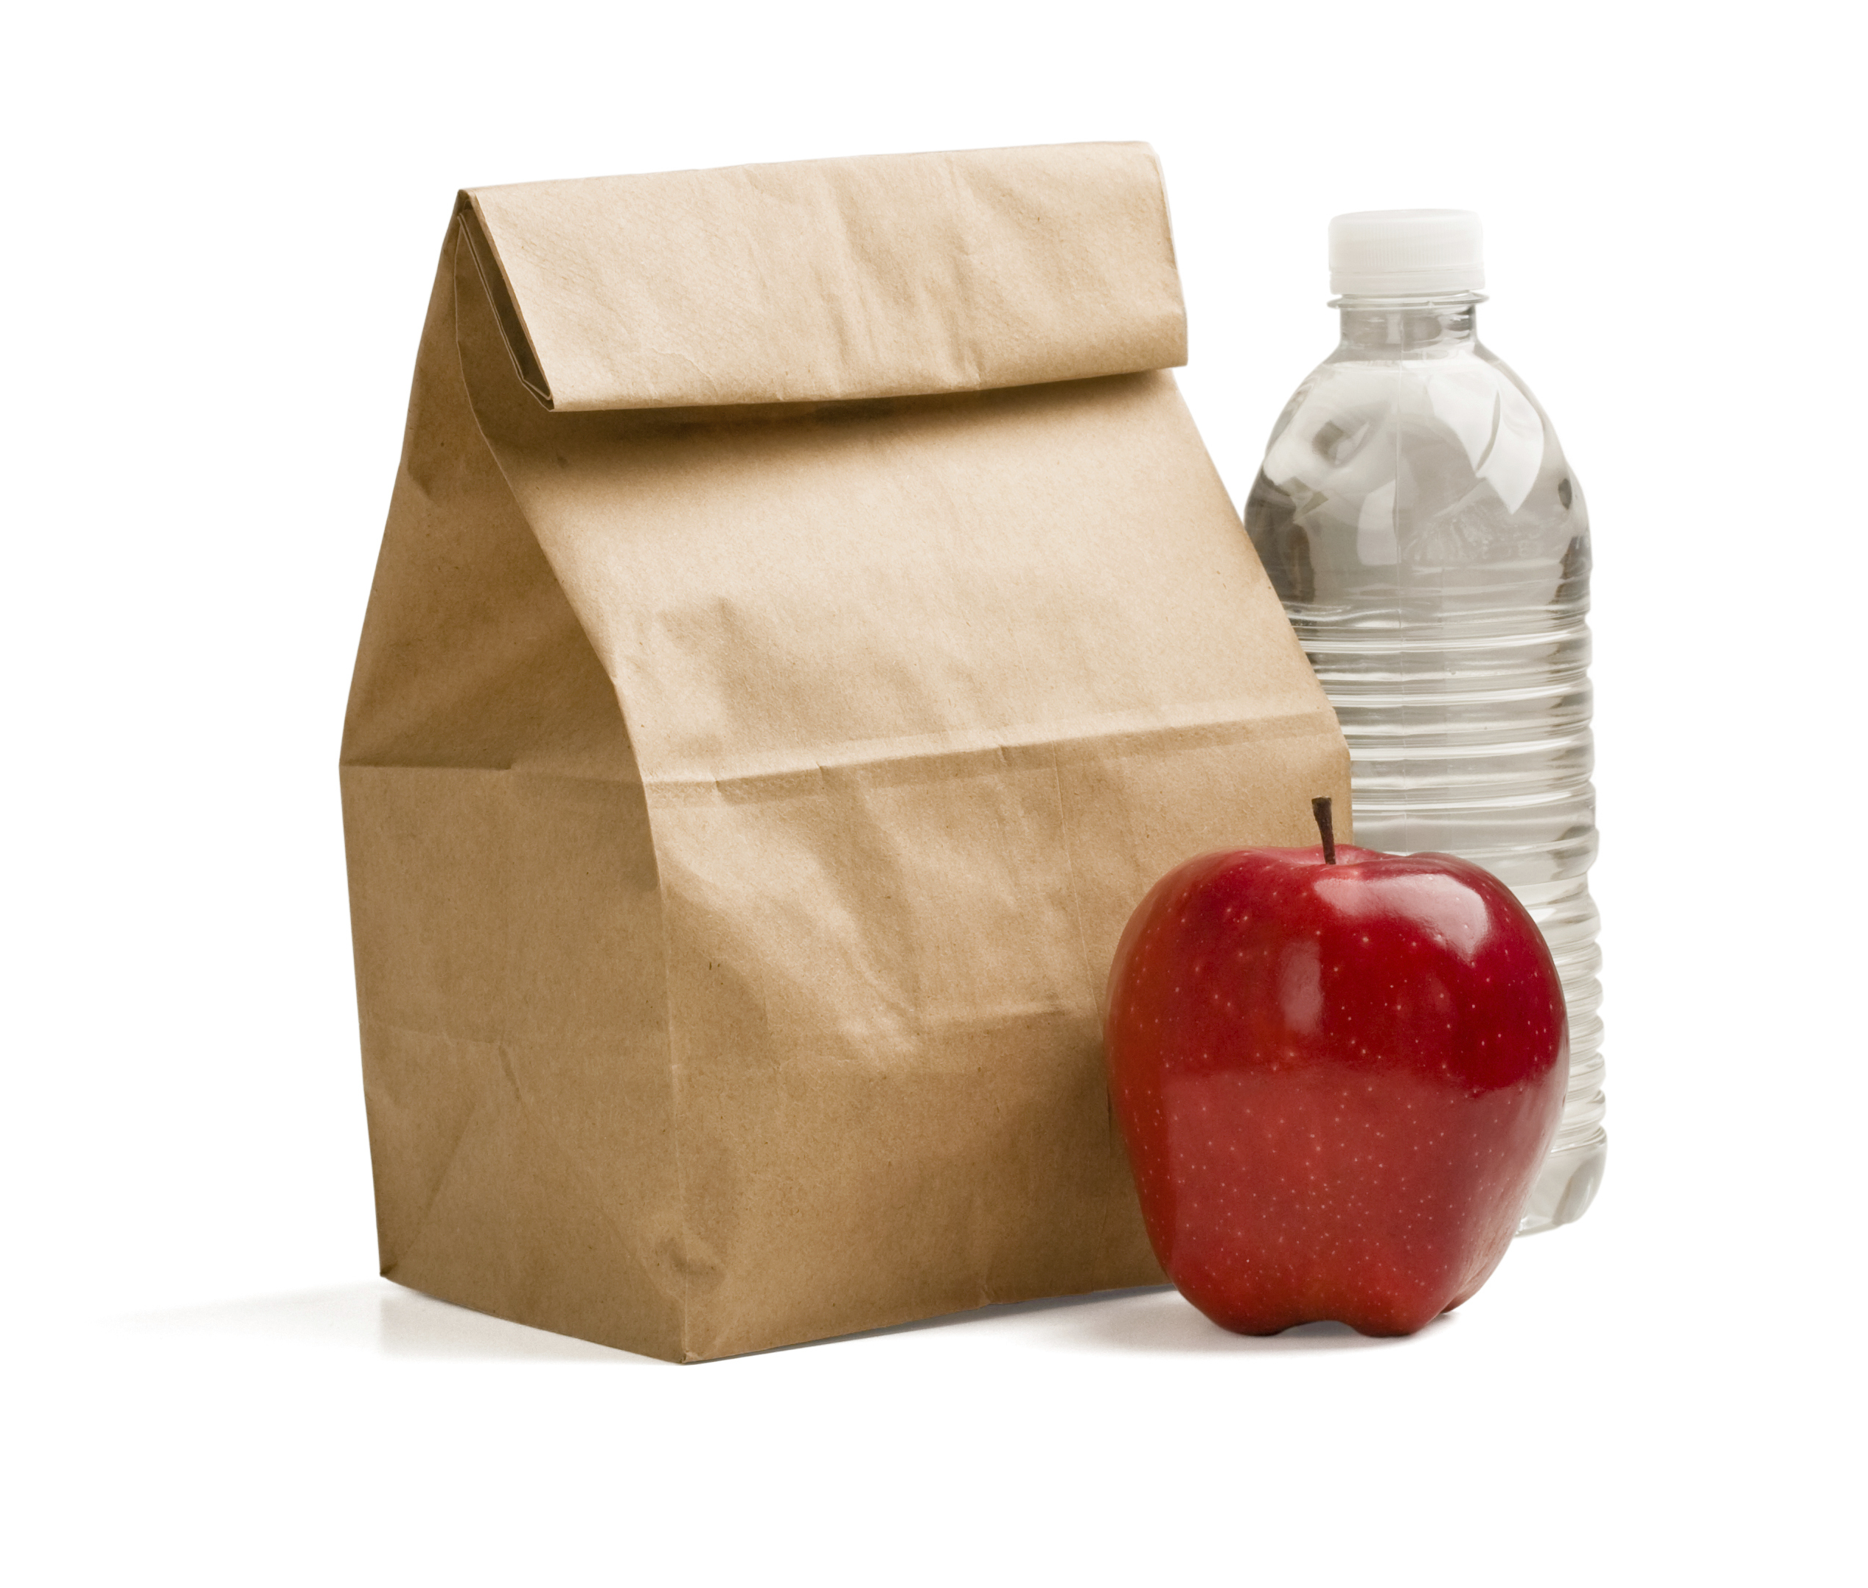
This refrigerator used for FOOD only.
ATTENTION
www.acponline.org/practiceforms

