The Feelings and Needs Exercise

Something I recently saw/heard/experienced (positive or negative) was:

When this happened I felt (choose 2-3 feelings from the list below):

I think I felt this way because I needed (choose 2-3 needs from the list below):

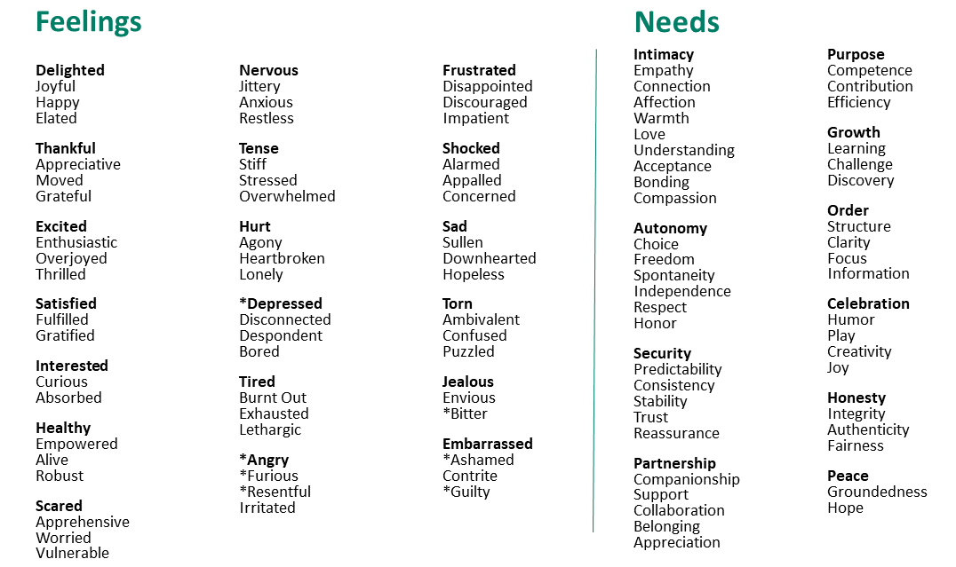

To meet the need(s) I just mentioned, I might be able to:

The first steps toward doing that could be:

If I did that I would feel (choose 1-3 feelings from the list above):

I am ready to commit to:

