Patients Before Paperwork Initiative
Reinvigorating the patient-physician relationship by challenging unnecessary and
excessive administrative burdens
“Putting Patients First by Reducing Administrative Tasks in Health Care: A Position Paper of the American College of Physicians”
As part of the Patients Before Paperwork iniative, ACP developed a position paper that provides a framework for identifying and evaluating administrative tasks and outlines detailed policy recommendations to reduce excessive administrative tasks across the health care system.

Figure 1: Framework for Analyzing Administrative Tasks
 |  | Sources
 |  | External |  |  |  |  | Internal
 | Intents
 | Products & Services |  |  | Quality & Safety |  | Cost & Fraud Reduction |  |  | Financial Security |  | Lack of Clear Intent
Impacts
Cost & Time – Billing/Insurance Related |  |  | Cost & Time – Measurement & Reporting |  |  | EHR/Health IT |  |  | Appropriate & Timely Patient Care |  | Physician Satisfaction & Burnout
Solutions
Assessment of Tasks by Stakeholders |  | Transparent Alignment & Streamlining of Tasks |  |  | Collaborate to Improve Quality Measures |  |  | Innovative Use of Health IT |  | Eliminate or Replace Duplicative Tasks |  |  | Research Impacts & Best Practices

Figure 2: Taxonomy for Categorizing Administrative Tasks as Worthwhile and Should Remain in Place, or Tasks that are Burdensome and Should Be Revised or Eliminated Entirely
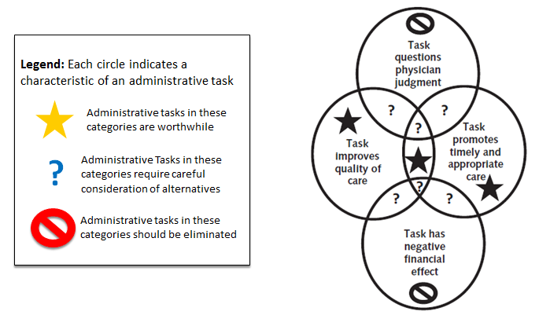

Policy Recommendations

- Stakeholders who develop or implement administrative tasks should provide financial, time, and quality of care impact statements for public review and comment.
- Tasks that cannot be eliminated must be regularly reviewed, revised, aligned and/or streamlined, with the goal of reducing burden.
- Stakeholders should collaborate to aim for performance measures that minimize unnecessary burden, maximize patient- and family-centeredness, and integrate measurement of and reporting on performance with quality improvement and care delivery.
- Stakeholders should collaborate in making better use of existing health IT, as well as develop more innovative approaches.
- As the US health care system evolves to focus on value, stakeholders should review and consider streamlining or eliminating duplicative administrative tasks.
- Rigorous research is needed on the impact of administrative tasks on our health care system.
- Research on and dissemination of evidence-based best practices to help physicians reduce administrative burden within their practices and organizations.

ACP Action Plan to Reduce Excessive Administrative Burdens
The College has developed an action plan to operationalize and promote the policy recommendations described in the paper:
- Advocacy Letters: ACP will send formal letters from ACP Leadership to the external stakeholders identified as sources of administrative burden including government oversight entities, EHR vendors, medical device companies, private and public payers, etc.
- Webinars and Listening Sessions: ACP will host webinars and listening sessions with key stakeholder groups to discuss types of administrative tasks faced by practicing clinicians and identify best practices and solution to reduce/streamline/eliminate excessive administrative tasks
- Collaborations with Other Groups: Staff will align with ACP’s broader efforts to promote physician wellness as well as align with external stakeholders actively working on reducing, streamlining, and eliminating excessive administrative tasks
- Medicare Advantage (MA) Policy Development: The College will develop policy recommendations to align administrative policies across all MA plans and promote transparency among MA plans regarding the intent of plan-specific requirements
- Reducing Administrative Burden Toolkit: The College has put together a list of resources to help individual members on practice-specific sources of administrative burden:
  - Individual Advocacy Letters: Letter templates for individual members to contact the external stakeholders they have identified as sources of administrative burden
  - Administrative Burdens Library: ACP will continue to compile a repository of internal and external administrative and regulatory burdens and best practices
  - PowerPoint Presentations: These can be used for chapter presentations and other educational opportunities
  - Current ACP Practice Resources: Practice Advisor®, Physician & Practice Timeline®, AmericanEHR, Medical Coding Resources, High-Value Care Coordination Resources, etc.

For more information, check out the following links:
- Patients Before Paperwork Initiative Website: https://www.acponline.org/advocacy/where-we-stand/patients-before-paperwork
- Contact us at policy-regs@acponline.org
- Discuss your issues on the Member Forum on Promoting Physician Wellness and Preventing Burnout: https://www.acponline.org/forums/promoting-physician-wellness-and-preventing-burnout

