Social Media for Influential Internists

Copy and paste the following social media posts for National Internal Medicine Day, October 28, 2021. To share the imagery, right click, select “save as...”

William Osler

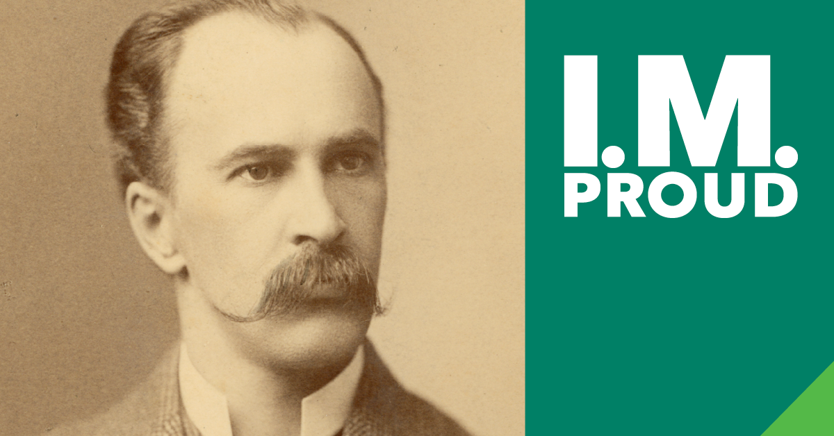

Facebook
Sir William Osler (1849-1919). Often referred to as the "doctor's doctor" and the father of modern clinical practice, Osler achieved extraordinary influence over modern-day medicine, most importantly through his support of clinical experience (or "bedside" learning) for medical students. Osler's The Principles and Practice of Medicine: Designed for the Use of Practitioners and Students of Medicine, published in 1892, became the standard textbook for physicians around the world and helped cement the movement away from exclusively textbook-based education towards clinic-based learning. #NationalInternalMedicineDay #IMProud @ACPinternists

Instagram
Sir William Osler (1849-1919). Often referred to as the "doctor's doctor" and the father of modern clinical practice, Osler achieved extraordinary influence over modern-day medicine, most importantly through his support of clinical experience (or "bedside" learning) for medical students. Osler's The Principles and Practice of Medicine: Designed for the Use of Practitioners and Students of Medicine, published in 1892, became the standard textbook for physicians around the world and helped cement the movement away from exclusively textbook-based education towards clinic-based learning. #NationalInternalMedicineDay #IMProud @ACPinternists

Twitter
William Osler (1849-1919). Often referred to as the father of modern clinical practice, Osler achieved extraordinary influence over modern-day medicine, including supporting bedside learning for medical students. #NationalInternalMedicineDay #IMProud @ACPinternists

Continued on next page….
Helen Brooke Taussig

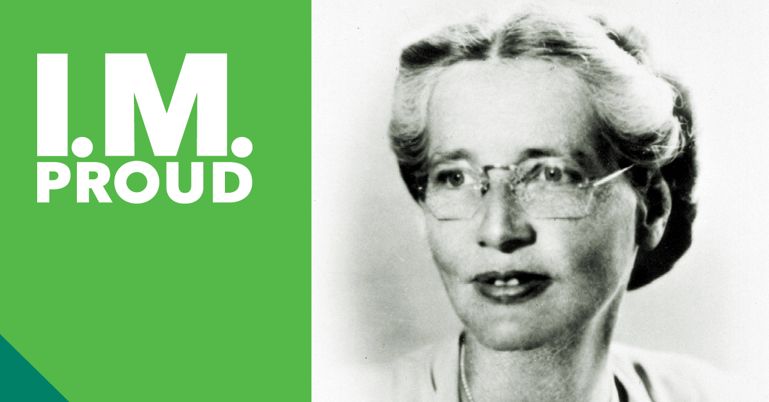

Facebook
Helen Brooke Taussig, MD, MACP (1898-1986), recognized as the founder of pediatric cardiology, is best known for her contributions to the Blalock-Thomas-Taussig shunt, a palliative procedure designed to increase pulmonary arterial blood flow in patients with right ventricular outflow tract obstruction or during initial staged repair of hypoplastic left heart syndrome. In 1972, Dr. Taussig became the first woman to be elected a Master of the American College of Physicians. #NationalInternalMedicineDay #IMProud @ACPinternists

Instagram
Helen Brooke Taussig, MD, MACP (1898-1986), recognized as the founder of pediatric cardiology, is best known for her contributions to the Blalock-Thomas-Taussig shunt, a palliative procedure designed to increase pulmonary arterial blood flow in patients with right ventricular outflow tract obstruction or during initial staged repair of hypoplastic left heart syndrome. In 1972, Dr. Taussig became the first woman to be elected a Master of the American College of Physicians. #NationalInternalMedicineDay #IMProud @ACPinternists

Twitter
Helen Brooke Taussig, MD, MACP (1898-1986) is recognized as the founder of pediatric cardiology. In 1972, Dr. Taussig became the first woman to be elected a Master of the American College of Physicians. #NationalInternalMedicineDay #IMProud @ACPinternists

Continued on next page….

Jonas Salk

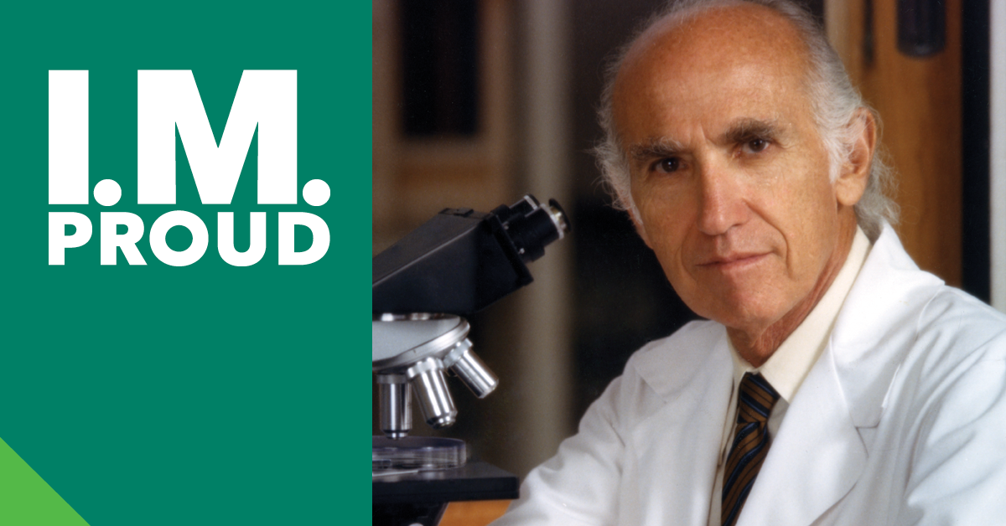

Facebook
Dr. Jonas Salk (1914-1995) is renowned for having developed the first safe and effective polio vaccine in the 1950s. He never patented the vaccine or earned any money from his discovery, preferring it be distributed as widely as possible. In 1960, Dr. Salk founded the Salk Institute for Biological Studies in San Diego. #NationalInternalMedicineDay #IMProud @ACPinternists

Instagram
Dr. Jonas Salk (1914-1995) is renowned for having developed the first safe and effective polio vaccine in the 1950s. He never patented the vaccine or earned any money from his discovery, preferring it be distributed as widely as possible. In 1960, Dr. Salk founded the Salk Institute for Biological Studies in San Diego. #NationalInternalMedicineDay #IMProud @ACPinternists

Twitter
Dr. Jonas Salk (1914-95) is renowned for having developed the first safe & effective polio vaccine in the 1950s. He never patented the vaccine or earned any money from his discovery. In 1960 Dr. Salk founded the @salkinstitute. #NationalInternalMedicineDay #IMProud @ACPinternists

Continued on next page….

Harriet Pearson Dustan

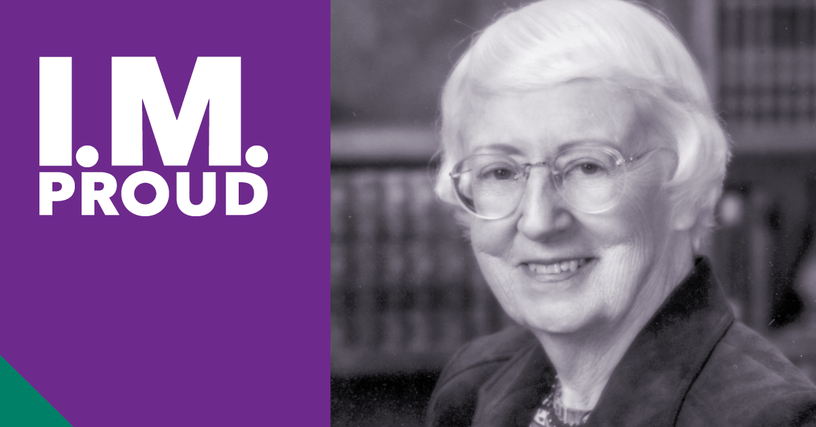

Facebook
Harriet Pearson Dustan, MD, MACP (1920-1999) was involved in a series of innovations in the detection and treatment of hypertension. In 1948, she joined the Research Division of the Cleveland Clinic and was among the first to suggest that reducing dietary sodium could lower hypertension and cardiac risks. In 1976, Dr. Dustan became the second woman to be elected a Master of the American College of Physicians. #NationalInternalMedicineDay #IMProud @ACPinternists

Instagram
Harriet Pearson Dustan, MD, MACP (1920-1999) was involved in a series of innovations in the detection and treatment of hypertension. In 1948, she joined the Research Division of the Cleveland Clinic and was among the first to suggest that reducing dietary sodium could lower hypertension and cardiac risks. In 1976, Dr. Dustan became the second woman to be elected a Master of the American College of Physicians. #NationalInternalMedicineDay #IMProud @ACPinternists

Twitter
Harriet Pearson Dustan, MD, MACP (1920-99) was involved in a series of innovations in the detection & treatment of hypertension. She was among the first to suggest that reducing dietary sodium could lower hypertension & cardiac risks. #NationalInternalMedicineDay #IMProud @ACPinternists

Continued on next page….

Basil Hirschowitz

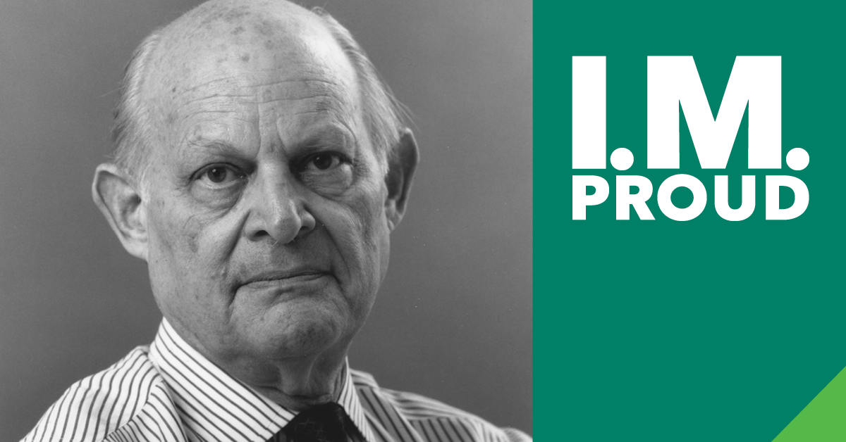

Facebook
Basil Hirschowitz, MD, PhD, MACP (1925-2013) dedicated his career to the study of physiology, pharmacology, and diseases of the upper GI tract. He along with colleagues Larry Curtis and C. Wilbur Peters, invented the first fiber-optic endoscope that became the standard for visualizing and treating virtually every cavity in the body. Dr. Hirschowitz’s major research initiatives throughout his career involved the normal gastric functions and pathophysiology of acid-peptic diseases such as peptic ulcer, reflux and, particularly, Zollinger-Ellison syndrome. #NationalInternalMedicineDay #IMProud @ACPinternists

Instagram
Basil Hirschowitz, MD, PhD, MACP (1925-2013) dedicated his career to the study of physiology, pharmacology, and diseases of the upper GI tract. He along with colleagues Larry Curtis and C. Wilbur Peters, invented the first fiber-optic endoscope that became the standard for visualizing and treating virtually every cavity in the body. Dr. Hirschowitz’s major research initiatives throughout his career involved the normal gastric functions and pathophysiology of acid-peptic diseases such as peptic ulcer, reflux and, particularly, Zollinger-Ellison syndrome. #NationalInternalMedicineDay #IMProud @ACPinternists

Twitter
Basil Hirschowitz, MD, MACP (1925-2013) dedicated his career to the study of upper GI tract diseases. He invented the first fiber-optic endoscope that became the standard for visualizing virtually every cavity in the body. #NationalInternalMedicineDay #IMProud @ACPinternists

Continued on next page….

David Sackett

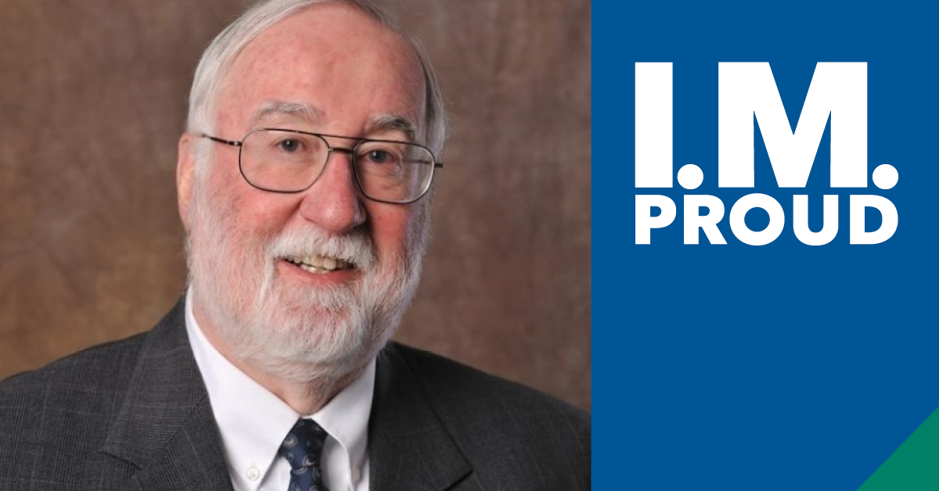

Facebook
David Sackett, MD (1934-2015) is considered the father of evidence-based medicine. A leader in the field of epidemiology, his innovations included creating research methods to test health care innovations and gauge scientific validity and educating clinicians to practice the "current best evidence from research." #NationalInternalMedicineDay #IMProud @ACPinternists

Instagram
David Sackett, MD (1934-2015) is considered the father of evidence-based medicine. A leader in the field of epidemiology, his innovations included creating research methods to test health care innovations and gauge scientific validity and educating clinicians to practice the "current best evidence from research." #NationalInternalMedicineDay #IMProud @ACPinternists

Twitter
David Sackett, MD (1934-2015). Dr. Sackett’s innovations included creating research methods to test health care innovations & gauge scientific validity & educating clinicians to practice the current best evidence from research. #NationalInternalMedicineDay #IMProud @ACPinternists

Continued on next page….

June Klinghoffer

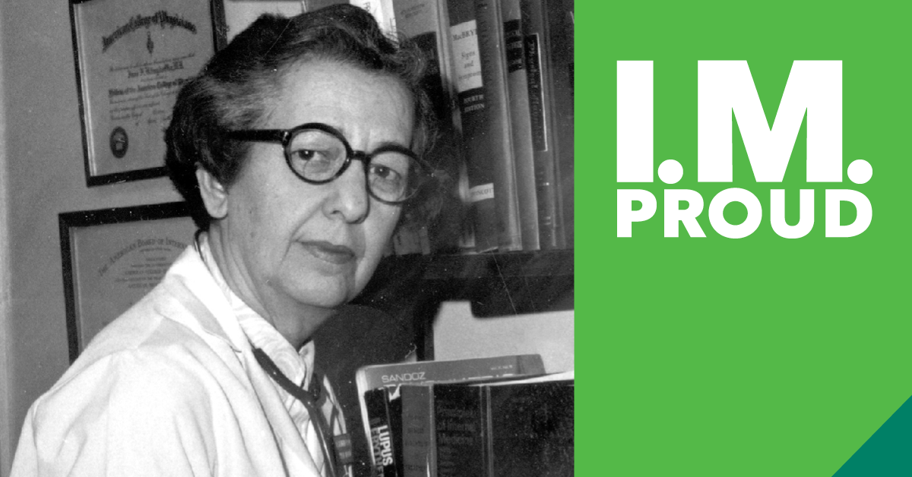

Facebook
June Klinghoffer, MD, FACP (1921-2008) was a pioneer for women in medicine. At a time when some thought it an inappropriate profession for a woman, Dr. Klinghoffer went on to inspire thousands of medical students during her 52 years teaching at the former Woman’s Medicial College of Pennsylvania, now @Drexel College of Medicine. #NationalInternalMedicineDay #IMProud @ACPinternists

Instagram
June Klinghoffer, MD, FACP (1921-2008) was a pioneer for women in medicine. At a time when some thought it an inappropriate profession for a woman, Dr. Klinghoffer went on to inspire thousands of #MedicalStudents during her 52 years teaching at the former Woman’s Medical College of Pennsylvania, now @DrexelMedicine. #NationalInternalMedicineDay #IMProud @acpinternists #InternalMedicine #medicine #healthcare #physician

Twitter
June Klinghoffer, MD, FACP (1921-2008) was a pioneer for women in medicine. When some thought it an inappropriate profession for women, Dr. Klinghoffer inspired thousands of medical students in her 52 years @DrexelMedicine. #NationalInternalMedicineDay #IMProud @ACPinternists

Continued on next page….

Joseph B. Kirsner

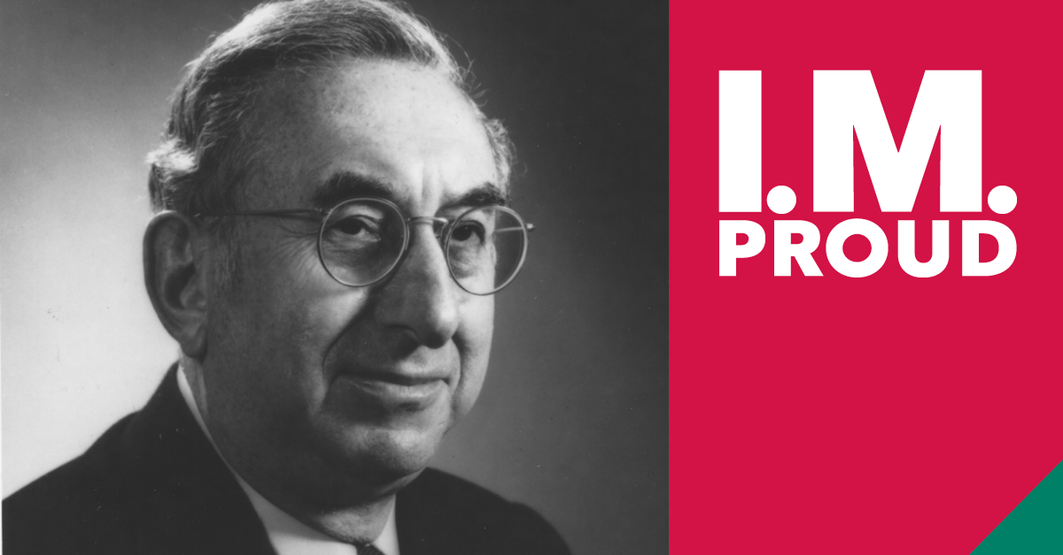

Facebook
Joseph B. Kirsner, MD, PhD (1909-2012) helped transform gastroenterology from an art into a science. His ground-breaking work led to a better understanding of inflammatory bowel disease. Dr. Kirsner was among the first to recognize the increased risk of colon cancer in patients with IBD. #NationalInternalMedicineDay #IMProud @ACPinternists

Instagram
Joseph B. Kirsner, MD, PhD (1909-2012) helped transform gastroenterology from an art into a science. His ground-breaking work led to a better understanding of inflammatory bowel disease. Dr. Kirsner was among the first to recognize the increased risk of colon cancer in patients with IBD. #NationalInternalMedicineDay #IMProud @ACPinternists

Twitter
Joseph B. Kirsner, MD, PhD (1909-2012). Dr. Kirsner’s ground-breaking work led to a better understanding of inflammatory bowel disease. He was among the first to recognize the increased risk of colon cancer in patients w/ IBD. #NationalInternalMedicineDay #IMProud @ACPinternists

Continued on next page….

E. Donnall Thomas

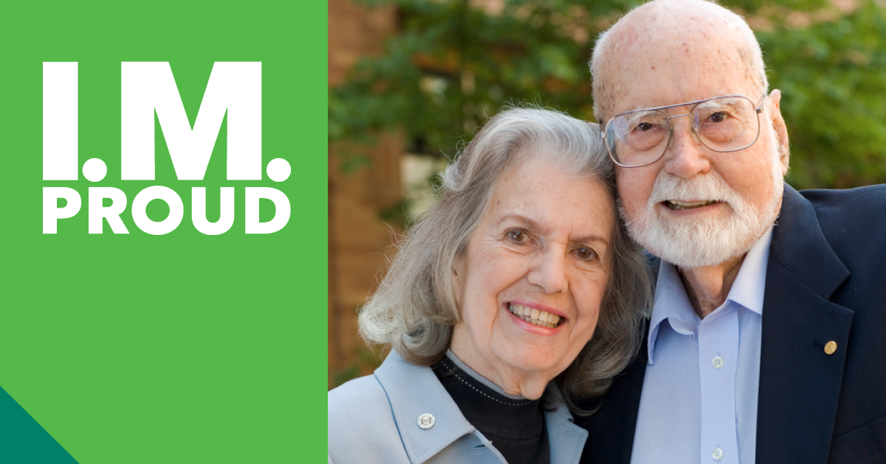

Facebook
E. Donnall Thomas, MD (1920-2012). The 1990 Nobel Prize laureate in physiology or medicine, Dr. Thomas, his wife Dottie, and others at Fred Hutchinson Cancer Research Center pioneered bone marrow transplantation, which has saved the lives of thousands of patients with blood cancer. #NationalInternalMedicineDay #IMProud @ACPinternists

Instagram
E. Donnall Thomas, MD (1920-2012). The 1990 Nobel Prize laureate in physiology or medicine, Dr. Thomas, his wife Dottie, and others at Fred Hutchinson Cancer Research Center pioneered bone marrow transplantation, which has saved the lives of thousands of patients with blood cancer. #NationalInternalMedicineDay #IMProud @ACPinternists

Twitter
E. Donnall Thomas, MD (1920-2012). A 1990 Nobel Prize laureate, Dr. Thomas, his wife Dottie, & others @FredHutch pioneered bone marrow transplantation, which has saved the lives of thousands of patients w/ blood cancer. #NationalInternalMedicineDay #IMProud @ACPinternists

Continued on next page….
Victor McKusick

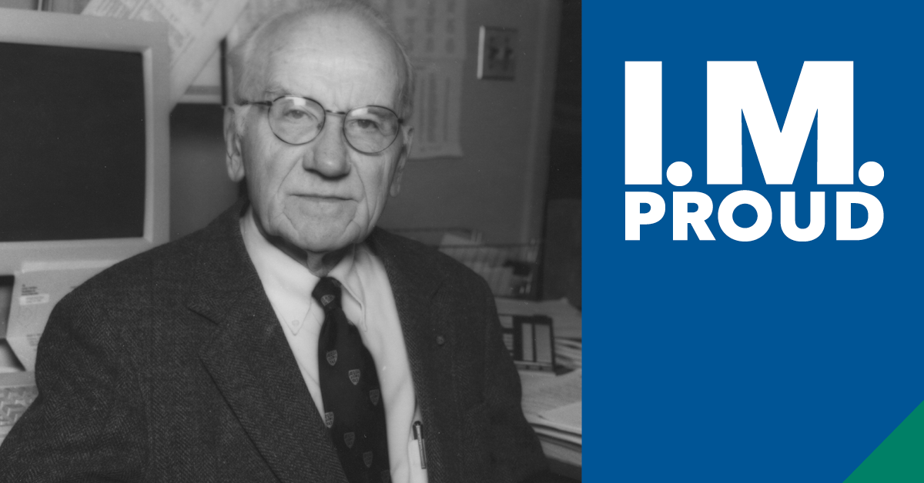

Facebook
Victor McKusick, MD (1921-2008) is considered the father of medical genetics. An early proponent of human genome mapping as a tool to study congenital diseases, he is well known for his genetics studies in Amish populations. In 1966, Dr. McKusick published Mendelian Inheritance in Man -- the first catalog of all known genes and genetic disorders. The online version became available in 1987 and remains a standard reference work. #NationalInternalMedicineDay #IMProud @ACPinternists

Instagram
Victor McKusick, MD (1921-2008) is considered the father of medical genetics. An early proponent of human genome mapping as a tool to study congenital diseases, he is well known for his genetics studies in Amish populations. In 1966, Dr. McKusick published Mendelian Inheritance in Man -- the first catalog of all known genes and genetic disorders. The online version became available in 1987 and remains a standard reference work. #NationalInternalMedicineDay #IMProud @ACPinternists

Twitter
Victor McKusick, MD (1921-2008). Considered the father of medical genetics, he is well known for his genetics studies of the Amish. In 1966, Dr. McKusick published the first catalog of all known genes and genetic disorders. #NationalInternalMedicineDay #IMProud @ACPinternists

Continued on next page….
W. Proctor Harvey

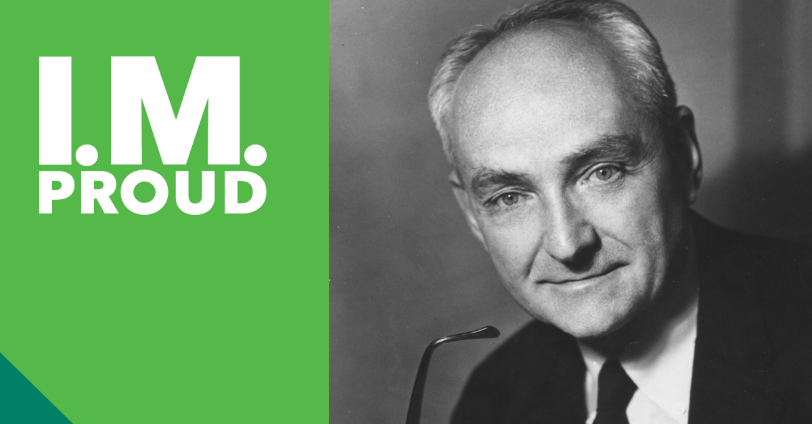

Facebook
W. Proctor Harvey, MD (1918-2007) was one of the 20th century's greatest clinical cardiologists. He was unmatched in the skill of clinical auscultation and in the art of physical diagnosis of cardiovascular disorders. Dr. Harvey’s weekly teaching conferences became standing room only events attracting physicians from all over the nation and the world. He invented an improved stethoscope and innovated audiovisual approaches to teaching cardiology. #NationalInternalMedicineDay #IMProud @ACPinternists

Instagram
W. Proctor Harvey, MD (1918-2007) was one of the 20th century's greatest clinical cardiologists. He was unmatched in the skill of clinical auscultation and in the art of physical diagnosis of cardiovascular disorders. Dr. Harvey’s weekly teaching conferences became standing room only events attracting physicians from all over the nation and the world. He invented an improved stethoscope and innovated audiovisual approaches to teaching cardiology. #NationalInternalMedicineDay #IMProud @ACPinternists

Twitter
W. Proctor Harvey,MD (1918-2007) was unmatched in the skill of clinical auscultation & art of physical diagnosis of cardiovascular disorders. He invented an improved stethoscope & innovated audiovisual approaches to teaching cardiology. #NationalInternalMedicineDay #IMProud @ACPinternists

Continued on next page….

Edith Irby Jones

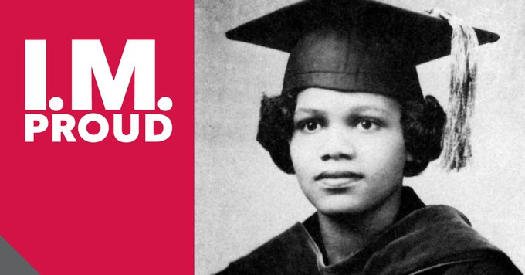

Facebook, Linkedin
Edith Irby Jones, MD (1927-2019), was a trailblazer who was the 1st African American to enroll and graduate from @UAMShealth and @Baylor College of Medicine, and the 1st woman president of the @NationalMedAssn. #NationalInternalMedicineDay #IMProud @ACPinternists

Instagram
Edith Irby Jones, MD (1927-2019), was a trailblazer who was the 1st African American to enroll and graduate from @uamshealth and the 1st woman president of the @nationalmedassn. #NationalInternalMedicineDay #IMProud @ACPinternists

Twitter
Edith Irby Jones, MD (1927-2019), was the 1st African American to enroll/graduate from @UAMShealth and the 1st woman president of the @NationalMedAssn. #NationalInternalMedicineDay #IMProud @ACPinternists

Continued on next page….
Anthony Fauci

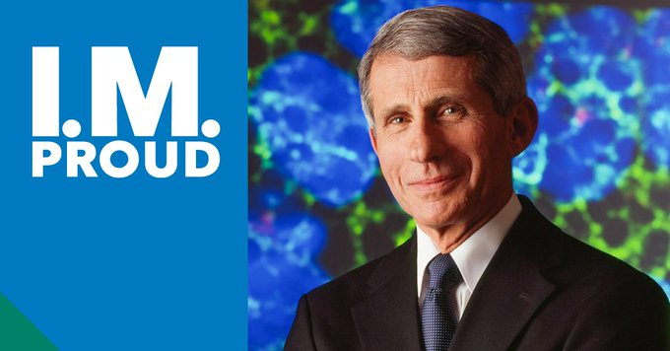

Facebook:
Anthony Fauci, MD, MACP, director of the @National Institute of Allergy and Infectious Diseases, has made substantial contributions to research on immune-mediated and infectious diseases, including #HIV/AIDS, and helped create @The U.S. President’s Emergency Plan for AIDS Relief (PEPFAR). #NationalInternalMedicineDay #IMProud @ACPinternists

Instagram:
Anthony Fauci, MD, MACP, director of @NIAID, has made substantial contributions to research on immune-mediated and infectious diseases, including #HIV/AIDS, and helped create the U.S. President’s Emergency Plan for AIDS Relief @PEPFAR. #NationalInternalMedicineDay #IMProud @ACPinternists

Twitter:
Anthony Fauci, MD, MACP, director of @NIAIDNews, has made substantial contributions to research on immune-mediated and infectious diseases, including #HIV/AIDS, and helped create the U.S. President’s Emergency Plan for AIDS Relief @PEPFAR. #NationalInternalMedicineDay #IMProud @ACPinternists

Continued on next page….
Lee Goldman

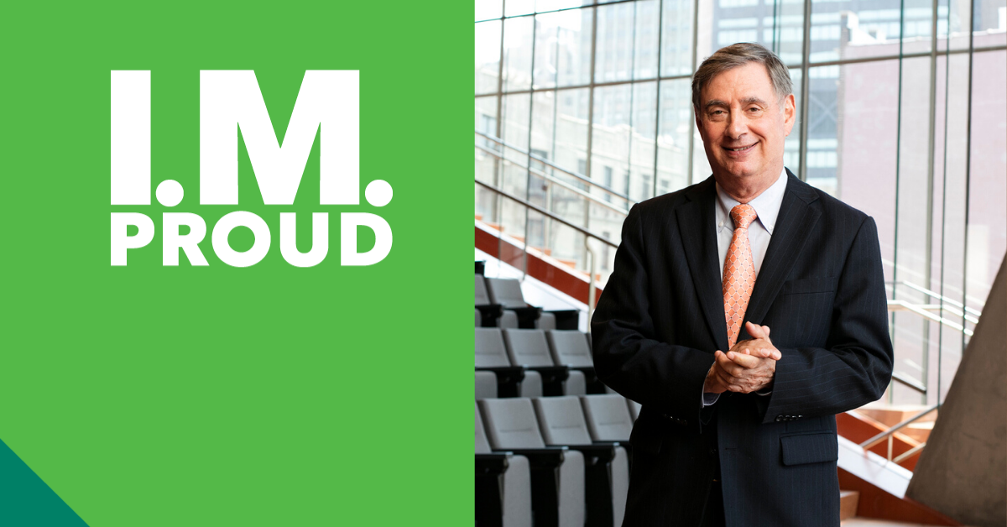

Facebook, Linkedin
Lee Goldman, MD, FACP, is professor and dean at @Columbia Public Health and CEO of the @Columbia University Irving Medical Center. He established the Goldman Index, the Goldman Criteria, and the Coronary Heart Disease Policy Model. Dr. Goldman, along with Dr. Robert Wachter, also coined the term #hospitalist. #NationalInternalMedicineDay #IMProud @ACPinternists

Instagram
Lee Goldman, MD, FACP, is professor and dean at @ColumbiaPublicHealth and CEO of the Columbia University Irving Medical Center. He established the Goldman Index, the Goldman Criteria, and the Coronary #HeartDisease Policy Model. Dr. Goldman, along with Dr. Robert Wachter, also coined the term #hospitalist. #NationalInternalMedicineDay #IMProud @ACPinternists

Twitter
Lee Goldman, MD, FACP, dean @ColumbiaMSPH & CEO @ColumbiaMed, established the Goldman Index, the Goldman Criteria, & the Coronary Heart Disease Policy Model. Dr. Goldman, along w/ Dr. Robert Wachter, also coined the term #hospitalist. #NationalInternalMedicineDay #IMProud @ACPinternists

Continued on next page….
Michael S. Brown, MD and Joseph L. Goldstein

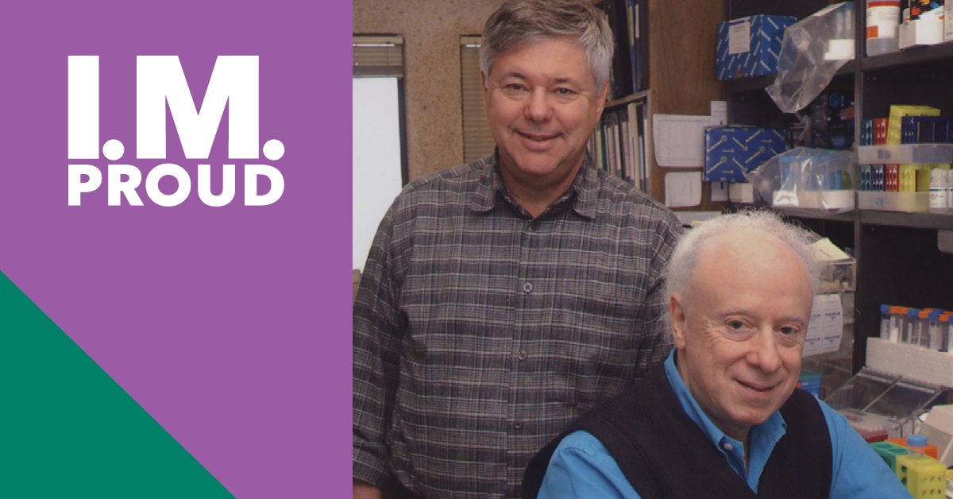

Facebook
Michael S. Brown, MD and Joseph L. Goldstein, MD, of @UT Southwestern Medical Center, received the @NobelPrize in Physiology or #Medicine for the discoveries concerning the regulation of cholesterol metabolism. #NationalInternalMedicineDay #IMProud @ACPinternists

Instagram
Michael S. Brown, MD and Joseph L. Goldstein, MD, of @utswnews, received the @NobelPrize in Physiology or #Medicine for the discoveries concerning the regulation of #cholesterol metabolism. #NationalInternalMedicineDay #IMProud @ACPinternists

Twitter
Michael S. Brown, MD and Joseph L. Goldstein, MD, of @UTSWNews, received the @NobelPrize in Physiology or #Medicine for the discoveries concerning the regulation of cholesterol metabolism. #NationalInternalMedicineDay #IMProud @ACPinternists

Continued on next page….

M. Elaine Eyster

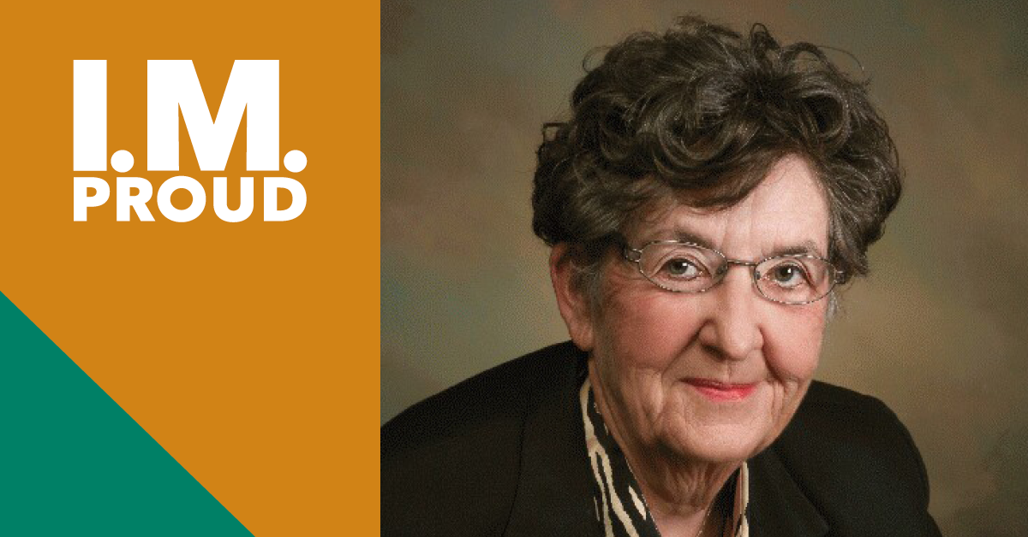

Facebook
M. Elaine Eyster, MD, FACP, @pennsthershey Cancer Institute, revolutionized the understanding of #HIV and #HepatitisC in #hemophilia patients. With current treatments, #HepC can be cured, while persons with HIV and Hemophilia can lead active lives. #NationalInternalMedicineDay #IMProud @ACPinternists

Instagram
M. Elaine Eyster, MD, FACP, @pennstatehershey Cancer Institute, revolutionized the understanding of #HIV and #HepatitisC in #hemophilia patients. With current treatments, #HepC can be cured, while persons with HIV and Hemophilia can lead active lives. #NationalInternalMedicineDay #IMProud @ACPinternists

Twitter
M. Elaine Eyster, MD, FACP, @pennsthershey Cancer Institute, revolutionized the understanding of #HIV and #HepatitisC in #hemophilia patients. #NationalInternalMedicineDay #IMProud @ACPinternists

Continued on next page….

Katrina Armstrong

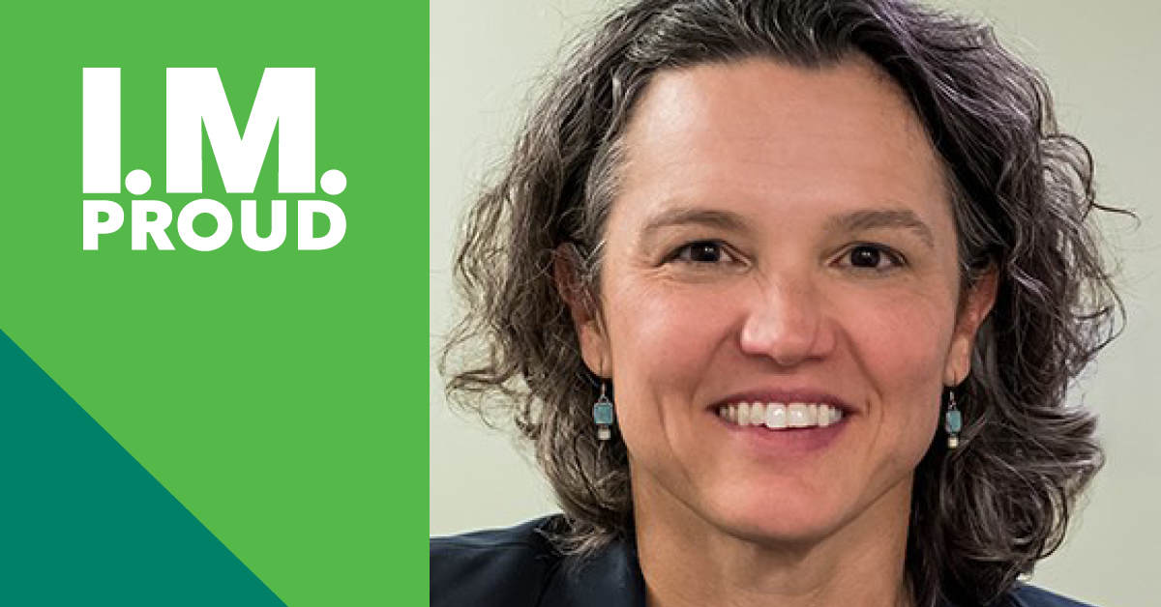

Facebook,
Katrina Armstrong, MD, FACP, chair of the Department of Medicine at Massachusetts General Hospital, is an internationally recognized investigator in medical decision making, quality of care, and #cancer prevention and outcomes. Dr. Armstrong has been elected to the American Society of Clinical Investigation, the American Academy of Arts & Sciences, and the National Academy of Medicine. #NationalInternalMedicineDay #IMProud @ACPinternists

Instagram
Katrina Armstrong, MD, FACP, chair of the Department of #Medicine at @MassGeneral, is an internationally recognized investigator in #medical decision making, quality of care, and #cancer prevention and outcomes. Dr. Armstrong has been elected to the American Society of #Clinical Investigation, the American Academy of Arts & Sciences, and the @National Academy of Medicine. #NationalInternalMedicineDay #IMProud @ACPinternists

Twitter
Katrina Armstrong, MD, FACP, chair of the Department of #Medicine at @MassGeneralNews, is an internationally recognized investigator in #medical decision making, elected to @the_asci, @americanacad & @theNAMedicine. #NationalInternalMedicineDay #IMProud @ACPinternists

Continued on next page….
Robert Wachter

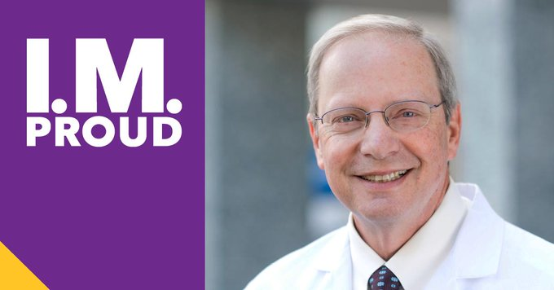

Facebook
Robert Wachter, MD, FACP, is Chair of the Department of Medicine @UCSF. Not only did he coin the term “hospitalist” with Dr. Lee Goldman, but Dr. Wachter is also considered the father of the #hospitalist field. In 2015, @ModernHealthcare magazine ranked him as the most influential physician-executive in the U.S. #NationalInternalMedicineDay #IMProud @ACPinternists

Instagram
Robert Wachter, MD, FACP, is Chair of the Department of Medicine @UCSFMed. Not only did he coin the term “hospitalist” with Dr. Lee Goldman, but Dr. Wachter is also considered the father of the #hospitalist field. In 2015, @modrnhealthcr magazine ranked him as the most influential physician-executive in the U.S. #NationalInternalMedicineDay #IMProud @ACPinternists

Twitter
Robert Wachter, MD, FACP, of @UCSFMedicine, coined the term “hospitalist” with Dr. Lee Goldman and is considered the father of the #hospitalist field. #NationalInternalMedicineDay #IMProud @ACPinternists @Bob_Wachter

Continued on next page….

Paul Volberding

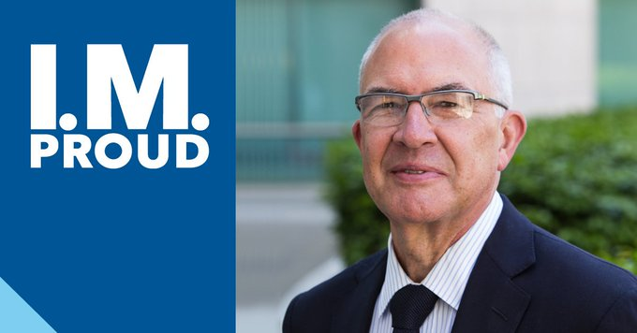

Facebook
Paul Volberding, MD, MACP, Director of @UCSF AIDS Research Institute, was at the forefront of the #AIDS epidemic in the early 1980s. Dr. Volberding founded the first inpatient ward for people with AIDS at San Francisco General Hospital. #NationalInternalMedicineDay #IMProud @ACPinternists

Instagram
Paul Volberding, MD, MACP, @UCSFMed, was at the forefront of the #AIDS epidemic in the early 1980s. Dr. Volberding founded the first inpatient ward for people with AIDS at San Francisco General Hospital. #NationalInternalMedicineDay #IMProud @ACPinternists

Twitter
Paul Volberding, MD, MACP, Director of @UCSF_ARI, was at the forefront of the #AIDS epidemic and founded the first inpatient ward for people with AIDS at San Francisco General Hospital. #NationalInternalMedicineDay #IMProud @ACPinternists @UCSFMedicine @pvolberding

Continued on next page….

Eric J. Topol

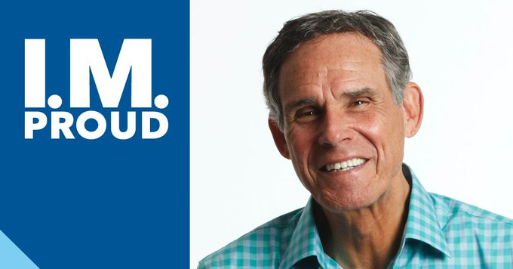

Facebook
@drerictopol, MD, FACP, founder and director of @ScrippsResearch Translational Institute, is one of the most cited researchers in #medicine. Dr. Topol has published three bestselling books on the future of medicine and, in 2012, @ModernHealthcare magazine ranked him as the most influential physician-executive in the U.S. #NationalInternalMedicineDay #IMProud @ACPinternists

Instagram
Eric J. Topol, MD, FACP, founder and director of @ScrippsResearch Translational Institute, is one of the most cited researchers in #medicine. Dr. Topol has published three bestselling books on the future of medicine and, in 2012, @modrnhealthcr magazine ranked him as the most influential physician-executive in the U.S. #NationalInternalMedicineDay #IMProud @ACPinternists

Twitter
.@EricTopol, MD, FACP, founder and director of @ScrippsResearch Translational Institute, is one of the most cited researchers in #medicine and the author of 3 bestselling books on the future of medicine. #NationalInternalMedicineDay #IMProud @ACPinternists

Continued on next page….

Lawrence Einhorn

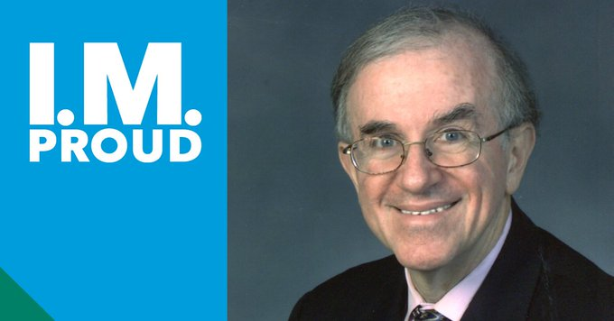

Facebook
Lawrence Einhorn, MD, MACP, of @IUMedicine, is a pioneer in #cancer treatment research. Dr. Einhorn developed cisplatin-based #chemotherapy that increased cure rates and minimized toxic side effects. #NationalInternalMedicineDay #IMProud @ACPinternists

Instagram
Lawrence Einhorn, MD, MACP, of @iumedschool, is a pioneer in #cancer treatment research. Dr. Einhorn developed cisplatin-based #chemotherapy that increased cure rates and minimized toxic side effects. #NationalInternalMedicineDay #IMProud @ACPinternists

Twitter
Lawrence Einhorn, MD, MACP, of @IUMedSchool, is a pioneer in #cancer treatment research. Dr. Einhorn developed cisplatin-based #chemotherapy that increased cure rates and minimized toxic side effects. #NationalInternalMedicineDay #IMProud @ACPinternists

Continued on next page…
Gerald Thomson

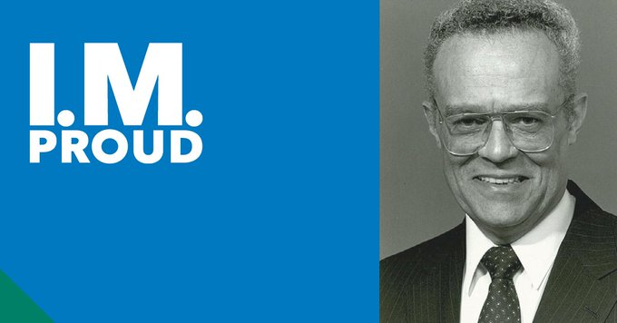

Facebook
Gerald Edmund Thomson, MD, MACP has enjoyed an illustrious career both in clinical medicine and health care policy. In 1995, he became the first African American to be elected President of ACP. A former Chairman of the American Board of Internal Medicine, today, Dr. Thomson maintains emeritus status for both of his professorships and as the Senior Associate Dean Emeritus of the Columbia University Vagelos College of Physicians and Surgeons. #NationalInternalMedicineDay #IMProud @ACPinternists

Instagram
Gerald Edmund Thomson, MD, MACP has enjoyed an illustrious career both in clinical medicine and health care policy. In 1995, he became the first African American to be elected President of ACP. A former Chairman of the American Board of Internal Medicine, today, Dr. Thomson maintains emeritus status for both of his professorships and as the Senior Associate Dean Emeritus of the Columbia University Vagelos College of Physicians and Surgeons. #NationalInternalMedicineDay #IMProud @ACPinternists

Twitter
Dr. Gerald Thomson has enjoyed an illustrious career in clinical medicine & #healthcare policy. In 1995, he became the first African American President of ACP. Today, he is Professor of Medicine Emeritus @ColumbiaPS. #NationalInternalMedicineDay #IMProud @ACPinternists

Continued on next page…

Faith Fitzgerald

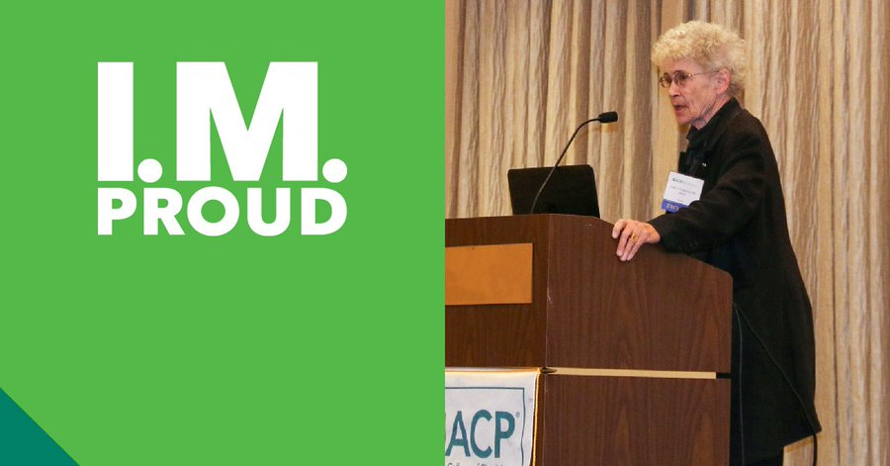

Facebook
Faith Fitzgerald, MD, MACP, professor at @UC Davis School of Medicine, has received dozens of teaching awards, including the ACP Distinguished #Teacher Award, and is widely recognized for highlighting the importance of doctor-patient interaction. #NationalInternalMedicineDay #IMProud @ACPinternists

Instagram
Faith Fitzgerald, MD, MACP, professor at @UCDavisMedSchool, has received dozens of teaching awards, including the ACP Distinguished #Teacher Award, and is widely recognized for highlighting the importance of doctor-patient interaction. #NationalInternalMedicineDay #IMProud @ACPinternists

Twitter
Faith Fitzgerald, MD, MACP, professor at @UCDavisMed, has received dozens of teaching awards, including ACP’s Distinguished #Teacher Award, and is widely recognized for highlighting the importance of doctor-patient interaction. #NationalInternalMedicineDay #IMProud @ACPinternists

Continued on next page…

Barry J. Marshall

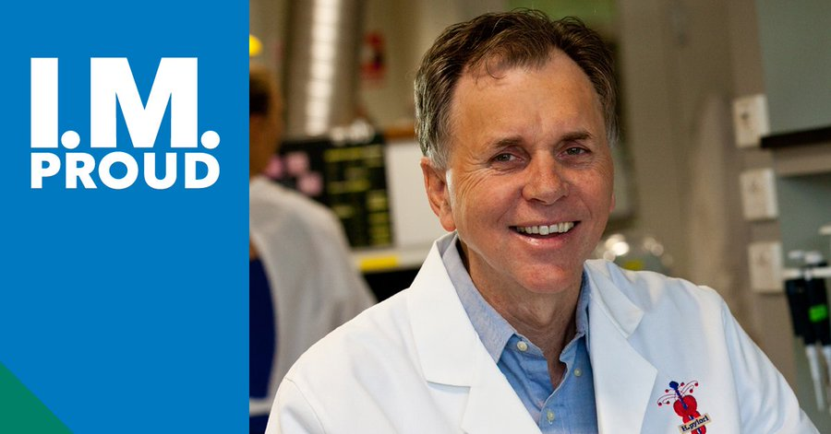

Facebook
Barry J. Marshall, MD, professor at @University of Western Australia, received the @NobelPrize in Physiology or #Medicine with Robin Warren for the discovery of bacterium Helicobacter pylori and its role in gastritis and peptic ulcer disease. #NationalInternalMedicineDay #IMProud @ACPinternists #NobelPrize

Instagram
Barry J. Marshall, MD, professor at @UniversityWA, received the @NobelPrize in Physiology or #Medicine with Robin Warren for the discovery of bacterium Helicobacter pylori and its role in gastritis and peptic ulcer disease. #NationalInternalMedicineDay #IMProud @ACPinternists #NobelPrize

Twitter
Barry J. Marshall, MD, professor at @uwanews, received the @NobelPrize in Physiology or #Medicine with Robin Warren for the discovery of bacterium Helicobacter pylori. #NationalInternalMedicineDay #IMProud @ACPinternists #NobelPrize @barjammar

