Mentoring Action Plan Worksheet

Creating a Mentoring Action Plan helps mentors and mentees work together to create a framework for their mentoring relationship.

Step 1: Define the goal the mentee hopes to achieve by the completion of the mentoring relationship. Ensure the goal is SMART.  Step 2: Identify strategic actions that help the mentee reach their goal.  Step 3: For each strategic action:  - Determine mentee’s action steps.  - Determine mentor’s action steps.  - Identify potential obstacles and challenges.  - Identify resources needed.  - Set a timeline for completion. | 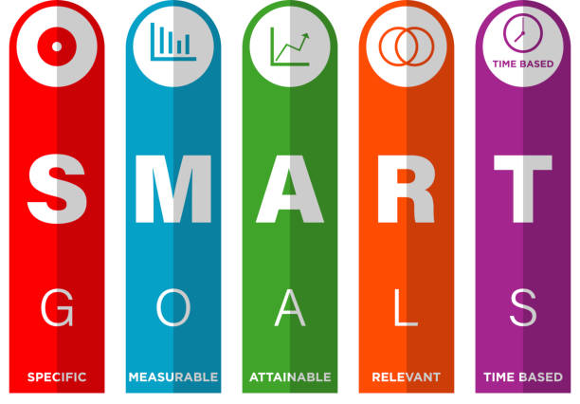

Goal
Strategic Action 1
Mentee Action Steps | Mentor Action Steps | Potential Challenges/Obstacles | Resources Needed | Projected Date of Completion
Success Measures
Notes

Strategic Action 2
Mentee Action Steps | Mentor Action Steps | Potential Challenges/Obstacles | Resources Needed | Projected Date of Completion
Success Measures
Notes

Strategic Action 3
Mentee Action Steps | Mentor Action Steps | Potential Challenges/Obstacles | Resources Needed | Projected Date of Completion
Success Measures
Notes

Strategic Action 4
Mentee Action Steps | Mentor Action Steps | Potential Challenges/Obstacles | Resources Needed | Projected Date of Completion
Success Measures
Notes

Strategic Action 5
Mentee Action Steps | Mentor Action Steps | Potential Challenges/Obstacles | Resources Needed | Projected Date of Completion
Success Measures
Notes

