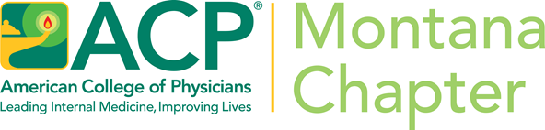
Call for Abstracts
Montana Chapter Scientific Meeting, September 11-12, 2025
St. Patrick Hospital, Missoula, Montana
Residents, Medical Students & Early Career Physicians
Requirements
To submit:
- Be a Montana ACP member. First authors must be Medical Student, Resident, or Early Career members of the Montana Chapter ACP or have applied for membership to enter this competition.
- Abstracts can only be submitted electronically through the Online Abstract Submission Form:
https://webforms.acponline.org/form/montana-chapter-abstract-form
3. To view ACP's guidelines and tips on preparing an abstract, visit http://www.acponline.org/residents_fellows/competitions/abstract/prepare/.

Deadline

The deadline for submitting entries is Friday, September 5th. No abstracts will be accepted after that time.
- ACP automatically sends you an immediate e-mail confirmation once your abstract has been successfully submitted.
- Please be sure to correctly enter your most current e-mail address when submitting your abstract as all communication regarding the abstract competition will be sent electronically to the email address that you provide.
Questions
For questions concerning this abstract competition, please contact Carrie Reisig at creisig33@gmail.com
Posters will be presented and judged on Thursday, September 11, at 5:30 pm.
One Resident/Fellow and one Early Career Physician will be eligible for a cash scholarship to attend the national competition during the Internal Medicine Meeting April 16-18, 2026, San Francisco, CA. Additional cash prizes will be awarded for second and third place and for the Medical Student winners.
We look forward to your participation.
Mike Spinelli, MD, FACP
Governor, ACP Montana Chapter

