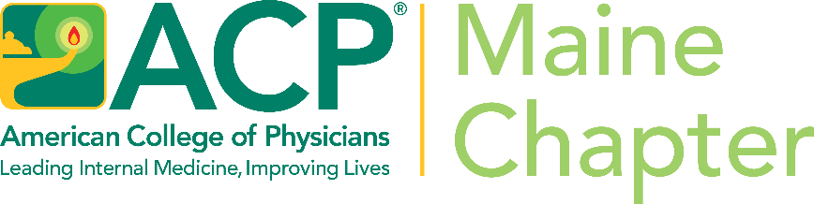

SAVE THE DATE
September 23 – 25, 2022

ACP Maine Chapter
Annual Chapter and Scientific Meeting

Atlantic Oceanside Resort and
Conference Center
Bar Harbor, ME

Vehicle Reservations are now
required for certain areas of
Acadia National Park.
Information regarding the park:
info:nps.gov/acad/planyourvisit/vehicle_reservations.htm

For reservations:
Reservation.gov

