ACP statements and commitments:
Past President Robert McClean, MD, MACP

Internists Say Harassment Based on Race or Ethnic Origin is Never Okay
Statement attributable to:
Robert McLean, MD, MACP
President, American College of Physicians
Washington, DC (March 31, 2020) — The American College of Physicians (ACP) strongly condemns any and all harassment, violence and discrimination based on an individual’s race, ethnic origin, ancestry or nationality. As our country and our health care system bear the overwhelming challenge of responding to the COVID-19 national emergency, this ethos is more important than ever. We are deeply concerned about reports of harassment against individuals of Asian descent, including physicians and other clinicians. At this challenging time our focus should be on respecting the dignity of others. We cannot allow prejudice and discrimination to divide us.
ACP has long fought against discrimination due to race, ethnic origin, nationality, cultural background and other personal characteristics. Our policies have called attention to the public health impact of hate crimes and discrimination, and to the harmful consequences of racial and ethnic disparities in health care. It is imperative that physicians, and all people, speak out against hate and discrimination.
***

Immediate Past President- Jacqueline Fincher, MD, MACP

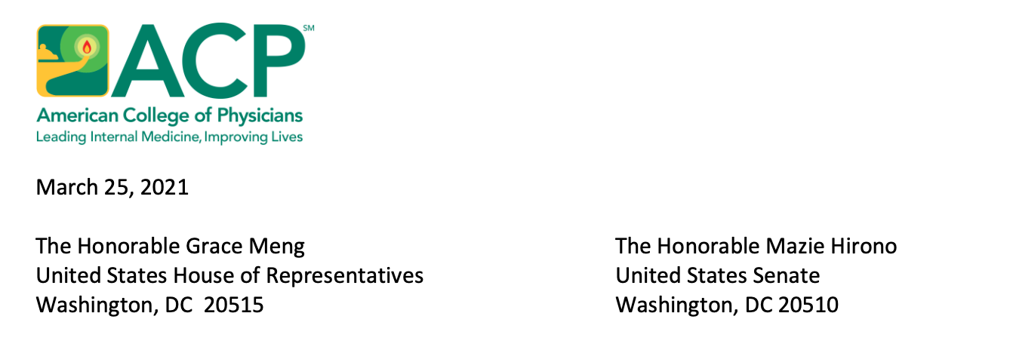
On behalf of the American College of Physicians (ACP), I am writing to express our strong support for the COVID-19 Hate Crimes Act, (H.R. 1843, S. 937), a bill that that would enhance the federal, state, and local response to hate crimes and violence related to the Coronavirus disease (COVID–19) pandemic, which is caused by severe acute respiratory syndrome coronavirus 2 (SARS-CoV-2). We commend you for taking this essential step to support the health and safety of our nation during a national crisis and a public health emergency (PHE) by proposing that Congress take direct action to respond to expressions of racism, xenophobia, discrimination, anti-Asian sentiment, scapegoating, and ethnic or religious intolerance. We especially share your alarm about reported incidents of harassment and violence against members of the Asian American and Pacific Islander (AAPI) community and ACP has spoken out strongly against these terrible acts in the past. The American College of Physicians is the largest medical specialty organization and the second-largest physician membership society in the United States. ACP members include 163,000 internal medicine physicians (internists), related subspecialists, and medical students. Internal medicine physicians are specialists who apply scientific knowledge and clinical expertise to the diagnosis, treatment, and compassionate care of adults across the spectrum from health to complex illness. Internal medicine specialists treat many of the patients at greatest risk from COVID-19, including the elderly and patients with pre-existing conditions like diabetes, heart disease and asthma. ACP strongly condemns any and all prejudice, discrimination, harassment and violence against individuals based on their race, ethnic origin, ancestry, gender, gender identity, nationality, primary language, socioeconomic status, sexual orientation, cultural background, age, disability, or religion. As our country and our health care system bear the overwhelming challenge of continuing to respond to the PHE caused by COVID-19, this ethos is more important than ever. We are deeply concerned and disturbed about the increasing reports of harassment against individuals of Asian descent, including physicians and other clinicians. At this challenging time, our nation’s focus should be on respecting the dignity of others. We cannot allow prejudice and discrimination to divide us. Hate crimes directed against individuals based on their race, ethnic origin, ancestry, gender, gender identity, nationality, primary language, socioeconomic status, sexual orientation, cultural background, age, disability, or religion are a true threat to the overall public health. ACP supports the development and implementation of anti-discrimination and hate crime laws. We applaud that the COVID-19 Hate 2 Crimes Act would: 1) require the U.S. Department of Health and Human Services (HHS), the COVID-19 Health Equity Task Force, and community-based organizations to work together to create guidance for the best ways to eliminate racially discriminatory language related to describing the COVID pandemic; 2) issue guidance for state and local law enforcement agencies to establish online hate crime reporting and expand culturally competent public education and to collect data to document the rise of incidences of hate crimes due to COVID-19; and 3) have the U.S. Department of Justice create a designated position to expedite review of COVID-19 hate crimes reported to federal, state, and local law enforcement. ACP policy supports the collection and publication of statistics on hate crimes. We also strongly believe that more research is needed about the impact of hate crimes on public health, understanding and preventing hate crimes, and effective interventions that address the needs of hate crime survivors and their communities. ACP has long fought against discrimination due to race, ethnic origin, nationality, cultural background and other personal characteristics. Our policies have called attention to the public health impact of hate crimes and discrimination, and to the harmful consequences of racial and ethnic disparities in health care. Therefore, it is imperative that physicians, and all people, speak out against hate and discrimination, especially during this national crisis caused by COVID-19. We applaud your leadership in bringing forth the COVID-19 Hate Crimes Act and urge Congress to now pass this bill in order to bring the necessary awareness, focus, and response to past and future acts of discrimination, harassment, and violence against members of the AAPI community due to COVID-19. As physicians, we are uniquely situated to speak out against these hateful, discriminatory, and violent acts and inform the public about why these acts are wrong and misguided. We look forward to working with you to advance this legislation through Congress and stand ready to serve as a resource for you about any matters regarding the COVID-19 PHE.

Sincerely, Jacqueline W. Fincher, MD, MACP
President

ACP Statement on Anti-Asian Racism, Violence, and Bias

In light of increasing anti-Asian attacks, violence, and hate crimes, (insert Chapter name(s) ) condemn(s) and denounce(s) all forms of anti-Asian racism, violence, and bias in the strongest possible terms.

We stand in solidarity with all victims of violence and their families as well as any fellow Pan Asian¹ community members facing anti-Asian attacks or discrimination.

These acts have escalated during the COVID-19 pandemic², and have targeted seniors, women, and children in particular.

There has been a long history of discrimination and exclusion against members of Pan Asian community, but these horrific events must not be viewed as separate from the hate and violence against any and all communities. Doing so contributes to the “invisibility” of the Pan Asian community within the broader dialogue and the chance to align in solidarity and allyship with other stakeholder communities.

Moreover, the Pan Asian communities are extremely diverse, and patients within these communities are among some of the most vulnerable and marginalized due to xenophobia as well as language and cultural barriers. We strongly advocate for culturally responsive and linguistically accessible resources, and for all individuals to be treated with dignity, respect, and equity.

Health is about more than those who receive care; it is also about those who provide it. Pan Asian physicians comprise over 17% of the U.S. physician workforce and over 22% of medical students in U.S. medical schools.³ Many Pan Asian members of the health care team encounter microaggressions, xenophobia, and bias in the course of their duties, putting their mental health and safety at risk. We support additional bystander intervention and de-escalation training; we support prioritizing the creation of safe spaces to mitigate these effects; and we encourage open discussion.⁴

The ACP considers hate crimes and discrimination to be public health issues, and has committed to further exploring discrimination and racism in health care, medical education, and society.⁵ In particular, the ACP condemns all forms of anti-Asian sentiment⁶ related to the Coronavirus (COVID-19) pandemic.⁷

May is Asian American and Pacific Islander Heritage Month. As we commemorate it, let us reaffirm our commitment to creating a climate of deeper understanding between different cultures and of mutual respect within our workplaces and communities. Also our commitment to building a more just, equitable, diverse, and inclusive space within medicine for patients and all members of the health care team.

Most importantly, let it be a time of healing for all.

Publication Date: May/June 2021

For more information or to join the ACP Pan Asian Affinity Group (APAAG) to stay updated about or get involved in upcoming related activities, contact the APAAG at:
Email: panasianaffinity@gmail.com
Twitter: @PanAsiansinIM
Instagram: @PanAsiansinIM
Website: https://sites.google.com/view/panasiansininternalmedicine/home

About the ACP Pan Asian Affinity Group

Statement on the Atlanta shootings – March 2021
The Massachusetts ACP Chapter expresses its heartfelt and deepest condolences to the families and loved ones of the victims of the Atlanta shootings earlier this week - Daoyou Feng, Paul Andre Michels, Hyeon Jeong Park, Julie Park, Xiaojie Tan, Delaina Ashley Yaun, and 2 as yet unidentified victims. While details surrounding the shootings continue to emerge, it is confirmed that the shooting victims were murdered by a 21-year-old white man who targeted Asian owned massage and spa businesses. Six out of the eight shooting victims were of Asian descent, and four of the eight were of Korean descent. All but one of the victims were women. This violence happened in the context of markedly increased incidence of anti-Asian racism, discrimination, bias, harassment, and violence, that has emerged with the COVID-19 pandemic. The shootings of earlier this week did not happen in a vacuum. Massachusetts ACP Chapter condemns racism, racially motivated violence, and hatred based on race, gender/gender identity, or any other self-identifying characteristic of individuals.
ACP has denounced anti-Asian racism in the wake of COVID-19, has addressed hate crimes as a public health issue, and supports anti-racism approaches to health:
Racism and Health in the United States: A Policy Statement From the American College of Physicians | Annals of Internal Medicine:
https://www.acpjournals.org/doi/full/10.7326/M20-4195
ACP Letter of Support for H Res 908:
ttps://www.acponline.org/acp_policy/letters/acp_letter_of_support_for_h_res_908_a_resolution_condemning_all_forms_of_anti-asian_sentiment_as_related_to_covid-19_april_2020.pdf
Internists Say Harassment Based on Race or Ethnic Origin is Never Okay | ACP Newsroom | ACP:
https://www.acponline.org/acp-newsroom/internists-say-harassment-based-on-race-or-ethnic-origin-is-never-okay
Respiratory Disease and Racism Have Reared Their Ugly Heads With COVID-19:
http://freshlook.annals.org/2020/03/respiratory-disease-and-racism-covid19.html
Massachusetts ACP Chapter stands with and supports our Asian/Asian American/pan-Asian community members, patients, colleagues, and physicians. We stand against racism and hatred. We commit to anti-racism. Together, supporting each other and our patients with compassion and empathy, we will be stronger.
Elisa I. Choi, MD, FACP, FIDSA
Governor, Massachusetts Chapter, American College of Physicians

Statement on Asian-American Violence and Discrimination
(March 2021) The events of the past week in the Atlanta area have highlighted the increasing violence and discrimination against Asian- Americans. We at Virginia ACP stand against such vile acts and will continue to work towards an antiracist and inclusive society for our patients and for all of us.
Our Diversity, Equity and Inclusion (DEI) committee is committed to this process, as stated by the following-
“The ACP Virginia Chapter will be a role model to swiftly speak out against systemic inequalities such as, but not limited to, racism, intolerance, sexism, classism, ageism, or other oppressive practices against marginalized sections of society. Our success is dependent on strong positive action for the culture to change.”
At the national level, ACP has been steadfastly working against Asian-American discrimination, as stated by Dr. Robert McLean, our former president-
“Washington, DC (March 31, 2020) — The American College of Physicians (ACP) strongly condemns any and all harassment, violence and discrimination based on an individual’s race, ethnic origin, ancestry or nationality. As our country and our health care system bear the overwhelming challenge of responding to the COVID-19 national emergency, this ethos is more important than ever. We are deeply concerned about reports of harassment against individuals of Asian descent, including physicians and other clinicians. At this challenging time our focus should be on respecting the dignity of others. We cannot allow prejudice and discrimination to divide us.”
Let us all work towards a vision of a more perfect union.
Stuart Henochowicz MD MBA FACP
Governor, ACP VA Chapter

Footnotes
1. Pan Asian: all people of Asian birth or descent; of, relating to, representing, or involving all the countries of Asia (including the South Asian subcontinent) as well as Native Hawaiians and non-Hawaiian Pacific Islanders.
2. Respiratory Disease and Racism Have Reared Their Ugly Heads With COVID-19:
http://freshlook.annals.org/2020/03/respiratory-disease-and-racism-covid19.html
3. AAMC Diversity in Medicine: Facts and Figures 2019
4. Lee, J. Combating Anti-Asian Sentiment — A Practical Guide for Clinicians. NEJM
March 24, 2021.DOI: 10.1056/NEJMp2102656
5. Josh Serchen, Robert Doherty, Omar Atiq, et al. Racism and Health in the United States: A Policy Statement From the American College of Physicians. Ann Intern Med.2020;173:556-557. [Epub ahead of print 19 June 2020]. doi:10.7326/M20-4195
6. Internists Say Harassment Based on Race or Ethnic Origin is Never Okay | ACP Newsroom: https://www.acponline.org/acp-newsroom/internists-say-harassment-based-on-race-or-ethnic-origin-is-never-okay
7. ACP Letter of Support for H Res 908:
https://www.acponline.org/acp_policy/letters/acp_letter_of_support_for_h_res_908_a_resolution_condemning_all_forms_of_anti-asian_sentiment_as_related_to_covid-19_april_2020.pdf

From ACP Hospitalist

Anti-Asian bias brought out by pandemic
Some physicians have fought discrimination along with the virus.
By Stacey Butterfield

Hospitalist Audrey Sue Cruz, MD, had heard about increased discrimination against Asian-Americans resulting from the COVID-19 pandemic, but a patient encounter really brought the problem home to her.
“I'm a hospitalist, but I also do primary care and so we've been doing a lot of telehealth visits, and I did one visit over the telephone with a new patient,” said Dr. Cruz. “At the end of the visit, she asked me what my nationality was. . . . I answered her, ‘I'm Filipino and Asian.’ She responded by saying, ‘Wow, I can't believe what your people did.’ And then she said, ‘I typically wouldn't choose an Asian doctor, but you seem nice.’”
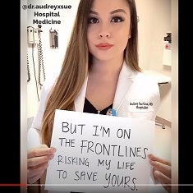Screenshot courtesy of Dr. Cruz.
Dr. Cruz, who practices at Loma Linda University Medical Center in California, was left shocked, uncomfortable, and glad the visit was near its natural end. “I asked her if she had anything else she wanted to talk about medically, because that's what I'm here for. . . . She didn't have any other questions, so we ended the visit.”
Recent incidents like this, and concerns about even more explicit racist attacks in the community, have motivated Dr. Cruz and other physicians to speak out against anti-Asian bias, individually and collectively.
Elisa I. Choi, MD, FACP, an internal medicine and infectious disease specialist and chief of internal medicine at a multi-specialty practice in the greater Boston area, said she started hearing about this type of bias right as the COVID-19 epidemic began in China. “I had started seeing reports on Twitter and social media that there were cases here and there of biased language or racist speech that were directed at the origins of the virus,” she said.
It's gotten even worse since, despite the efforts of health care leaders to avoid the problem, for example, by not naming the virus geographically, she added. “As the pandemic has continued, the anti-Asian racism has really only picked up steam.”
Whether the racism is occurring within health care or outside, Dr. Choi believes it's important for physicians to respond to it. “Our job as medical professionals and practitioners of evidence-based medicine is to also make sure that our patients understand what's actually authentic truth and medical facts, and not to help perpetuate some of that false narrative,” she said.
Among other problems, biased beliefs about the virus may actually impair patients' understanding of their health, she said. “This has happened to numerous colleagues that I've had the chance to speak with, and I've certainly seen it in my own health care practice: Some patients, when they're asked, ‘What's your risk factor for COVID-19 exposure?’ will start to mention, ‘Well, I was surrounded by a group of Asians.’”
Dr. Choi tries to educate such patients on an individual level with a response like, “That has no bearing on whether you have a risk for COVID-19.” But she worries about how such attitudes could be dramatically more detrimental to the health of those subject to the bias.
“This false view that anyone of Asian descent is somehow to blame or somehow a carrier can have a tremendous impact on an individual's desire to even seek medical care,” she said. Dr. Choi is concerned that some members of the Asian community might be reluctant to seek care if they do develop COVID-19, but “We don't know if that's happening because it's really hard to measure.”
They might even be nervous to leave their homes. “Being of Asian-American descent, we think about our parents and our grandparents and how helpless and innocent they are, and we worry about them when they go out,” said Dagny Zhu, MD, an ophthalmologist in Rowland Heights, Calif. “I think it's important, for those who are able, to speak up for those who are normally voiceless and have less of a say in society.”
Dr. Zhu and a group of colleagues, including Dr. Cruz, used an online video to speak up against the hate. The two-minute video, posted on YouTube and shared widely on social media, features Asian-American doctors, some holding signs with anti-Asian statements, others holding responses such as, “But I'm on the frontlines risking my life to save yours.”
“We really just want to spread a positive message to promote kindness and unity so that we can, instead of tearing each other apart, unite and fight this pandemic together,” said Dr. Zhu.
Dr. Choi and her ACP colleagues, meanwhile, highlighted the issue in medical publications. She was the lead author of a March 18 article on the Annals Fresh Look blog titled “Respiratory Disease and Racism Have Reared Their Ugly Heads With COVID-19,” which reminded physicians that “promoting empathy, mutual respect, inclusion, and equality can be as important as accurate communication, diagnosis, and treatment.”
That was soon followed, on March 31, by an official ACP statement condemning harassment, violence, and discrimination based on an individual's race, ethnic origin, ancestry, or nationality. “We are deeply concerned about reports of harassment against individuals of Asian descent, including physicians and other clinicians,” said the statement from Robert M. McLean, MD, MACP, then President of ACP.
Dr. Choi, who is the Governor for ACP's Massachusetts Chapter, had advocated for this statement and was also involved in the College's endorsement of a congressional resolution condemning anti-Asian sentiment related to COVID-19. “It definitely makes me very proud to be part of the organization that recognizes things like hate crimes are not separate and distinct from caring for our patients,” she said.
This pandemic is not the first time that a disease has led to racial or ethnic discrimination, she noted. It's been a problem from the plague centuries ago through the early days of the HIV/AIDS epidemic. “When [AIDS] first emerged, there seemed to be some epidemiologic association with individuals of Haitian background. And so there was some element of racialization and targeting,” which led to both stigma and psychological trauma, said Dr. Choi.
Anti-Asian bias has also been a longstanding problem in the U.S., the physicians noted. “I think the first law excluding a group of immigrants was against Chinese immigrants, and so we've had a long history,” said Dr. Zhu.
Racism is a health care issue on multiple levels, noted Dr. Choi. “That has so many downstream effects, ultimately, not just in physical health for lack of seeking care, but we're starting to also recognize the mind-body connection, and having an ongoing sense of psychological stress likely has effects on physical health.”
That stress is also the last thing that clinicians need for themselves right now. “As a hospitalist, we don't get to choose our patients, obviously,” said Dr. Cruz. “What I want people to know is that we all are working as hard as we can, and our main focus is the health and safety and well-being of our patients.”
For some Asian-American physicians, there is a second battle, noted Micah Yu, MD, a rheumatology fellow at Loma Linda and participant in the video. “On top of the coronavirus that we're all fighting as health care professionals, some of our colleagues might be fighting the racism virus at the same time,” he said.
Note: Dr. Choi's opinions are her own and she is not speaking as an official representative of any organization with which she is affiliated.

Examples of websites, videos and articles:

On handling microaggressions in training:
https://onlinelibrary.wiley.com/doi/10.1002/pmrj.12229

Inappropriate patient and family behavior:
https://jamanetwork.com/journals/jamainternalmedicine/article-abstract/2701633

[HTML] Combating Anti-Asian Sentiment—A Practical Guide for Clinicians
https://www.nejm.org/doi/full/10.1056/NEJMp2102656

Racism in the USA: ensuring Asian American health equity ...
www.thelancet.com › PIIS0140-6736(21)00769-8 › fulltext

Apr 3, 2021 — Racist anti-Asian incidents and rhetoric in the USA have been on the rise during the COVID-19 pandemic, by some accounts increasing as ...

Anti-Asian Bias - A Guide for Educators
Ad·www.learningforjustice.org/

Speak up against racism and start conversations. Resources to help you address anti-Asian bias in the classroom and community. Civil Rights History. Teaching Kits. Film Kits.
‎Classroom Resources · ‎Build a Learning Plan · ‎Anti-Bias Resources · ‎Free Lesson Plans

What You Can Do About - Anti-Asian Racism
Ad·www.afsc.org/

Resources and Tools to Help You Stand Against Anti-Asian Racism. Because We All Deserve Safety and Peace In Our Communities. Highlights: Donation Option Available, BBB Accredited Charity.
‎Get Email Updates · ‎Donate Now

A History of Anti-Asian Hate - Anti-Asian Violence in America
Ad·www.npca.org/

Unfortunately, anti-Asian violence is deeply rooted in American culture. Learn more. Recent racist attacks targeting AAPI communities are not new to American history. Tax-Deductible. Protecting National Parks. BBB Accredited Charity. Top-Rated Great Nonprofit. Nonpartisan.
‎Read NPCA's Latest News · ‎Take Action · ‎Join NPCA · ‎Speaking Up For The Parks

Standing up to anti-Asian racism

With increasing reports of attacks on Asians in the U.S., here are some ways you can help respond to racism and build the safe and peaceful communities we all deserve.

ENDING WHITE SUPREMACY
Reports of anti-Asian violence and harassment continue to rise—including the horrific murders of six Asian women in a mass shooting in Atlanta in March. AFSC stands with the Asian American community against anti-Asian violence, rhetoric, and all forms of racism. (Read more from AFSC staff).
And today it is as critical as ever that we do all that we can to stop it in its tracks.

From March 19, 2020 through March 31, 2021, there were 6,603 incidents of verbal harassment, shunning, and physical assault on Asian Americans across the U.S. reported to the STOP AAPI (Asian American/Pacific Islander) HATE reporting center. Asians of all ethnicities are being racially profiled, and women make up 65% of the reports, the group says. Asian Americans face coronavirus discrimination in public and at businesses, especially grocery stores, pharmacies, and big box retail stores.
Incidents include physical attacks, denial of service at hotels, verbal abuse of AAPI workers, and xenophobic messages communicated by leaders in government.
This isn’t unlike the situation faced by Muslims after 9/11. And just as Islamophobic actions are targeted at both people who are actually Muslim and those perceived to be Muslim, COVID-19 racism has real consequences for Asian Americans who are Chinese or perceived to be Chinese. The harassment of AAPI women is especially concerning, with perpetrators often using the pretext of the coronavirus to perpetuate misogyny. Cynthia Choi, co-executive director of Chinese for Affirmative Action, says “I feel like the coronavirus is being weaponized.”
People targeted by COVID-19 racist attacks—who are dealing with the devastating impacts of the pandemic like everyone else—can feel further isolated and anxious. Tuyet Anh, a member of the National Asian Pacific American Women's Forum (NAPAWF), says that her experience with harassment “makes me and other Asian Americans feel as if we are the virus. We are labeled and demonized as this threat to white American safety.”
Amanda Nguyễn of Oakland, California created a viral video about the recent attacks and told reporters "When I made that video I was tired of living in fear and I wanted to scream. ... We are literally fearing for our lives as we walk out of our door.”
In these times, it’s important to remember the damaging narratives and scapegoating that occurred in other painful periods in our history—resulting in the Chinese Exclusion Act of 1882, the Immigration Act of 1924, and Japanese internment in the 1940s.
Very relevant to the murders in Atlanta, we can go back even further to The Page Act of 1875, used to exclude women who were suspected of prostitution or having “immoral” purposes. Tamara K. Nopper writes that “The Page Act was partly informed by images of Chinese women being dominated by Chinese men and Chinese culture while Chinese women simultaneously being viewed as sexual threat or predator that was being imported into the U.S. (and often assumed to be doing so against their will).” Although gendered and sexual violence exist in every culture, The Page Act racialized it as specific to the Chinese.
In AFSC’s workshops on anti-Muslim racism, we trace the roots of these damaging narratives that have targeted the AAPI community over centuries, as articulated by Edward Said in his classic work “Orientalism.” Simply put, the European or “Western” world has viewed Asian, Black, and other “non-Western” people through a lens that paints them as monolithic and dangerous, among other things. These narratives—which are still prevalent in our society and reinforced through education and entertainment—undergird our collective anxieties about public health in this moment.
It’s as important today as ever to educate ourselves and our community about these issues, stand up to racism wherever we see it, and work to build the safe, inclusive communities we all deserve.
Bystander Intervention:
- Do’s and don’ts for bystander intervention (AFSC). (below)
- How to respond to coronavirus racism (Teaching Tolerance)
Report Instances of anti-Asian harassment:
- Stand Against Hatred website (Asian Americans Advancing Justice)
- Stop AAPI Hate reporting website (Asia Pacific Policy Planning Council)
More tools:
- Know your rights during COVID-19 (Vision Change Win)
- Self-care tips for Asians dealing with COVID-19 racism (Huffington Post)
- Anti-stigma social media toolkit for public health (Seattle and King County)
- Racial Justice & Social Equity Resource List (Racial Equity Tools)

How to intervene if someone is being harassed

Bystander intervention do's and don'ts

Have you ever wondered what should you do if you witness public instances of racist, anti-Black, anti-Asian, anti-Muslim, anti-Trans, or another form of oppressive interpersonal violence or harassment?
As white supremacist violence is on the rise, it is more important than ever that we know how to keep each other safe. Use these tips to assess how to intervene while considering the safety of everyone involved.

The do's and don'ts of bystander intervention
DO make your presence as a witness known. If possible, make eye contact with the person being harassed and ask them if they want support. Move yourself near the person being harassed. If you feel you can risk doing so, create distance or a barrier between the person being harassed and the attacker. If it’s safe to do so—and the person being harassed consents—film or record the incident.
DO take cues from the individual being harassed. Is the person engaging with the harasser or not? You can make suggestions, “Would you like to walk with me over here? Move to another train car? For him to leave you alone?,” and then follow their lead. Notice if the person being harassed is resisting in their own way, and honor that. (Especially white folks, don’t police the tone of the person being harassed). Follow up with the individual being harassed after the incident is over, see if they need anything else.
DO keep both of you safe. Assess your surroundings—are there others nearby you can pull in to support? Working in a team is a good idea, if it is possible. Can you and the person being harassed move to a safer space/place?
DON'T call the police. For many communities experiencing harassment right now (including Arab and Muslim communities, Black people, queer and trans folks, and immigrants) the police can cause a greater danger for the person being harassed.
DON'T escalate the situation. The goal is to get the person being harassed to safety, not to incite further violence from the attacker.
DON'T do nothing. Silence is dangerous—it communicates approval and leaves the victim high and dry. If you find yourself too nervous or afraid to speak out, move closer to the person being harassed to communicate your support with your body.

DOWNLOAD THE DO'S AND DON'TS FOR BYSTANDER INTERVENTION POSTER

Also available in Spanish
Top of Form
First name:
Last name:
Email:
Bottom of Form
DOWNLOAD PDF

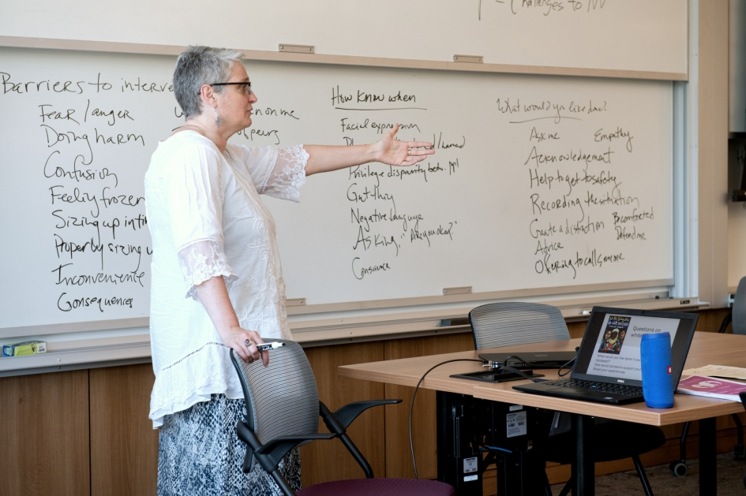

4Ds: Learn how to Distract, Delegate, Direct, and Delay

Use these practical tips on de-escalating instances of harassment and oppressive interpersonal violence. Content adapted by AFSC from Abbey Fox, Thought Catalogue, Jes Skolnik, Hollaback, and the People’s Response Team.
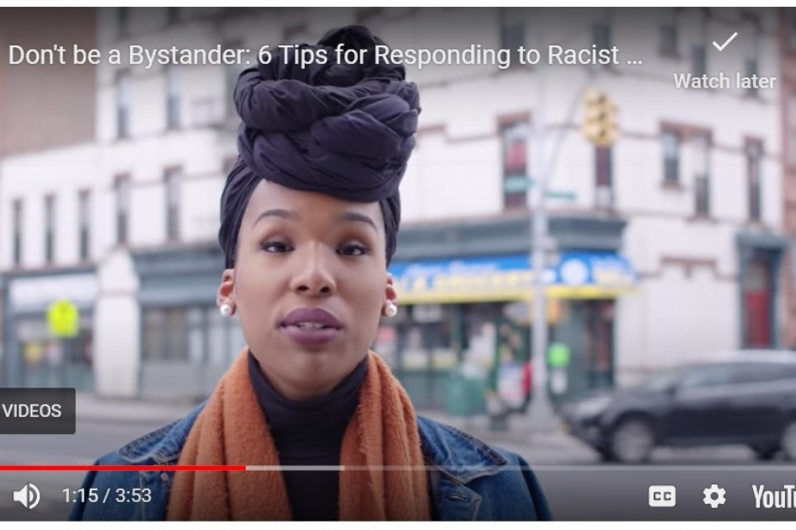

Don't Just be a Bystander

Watch this video for quick tips on responding to racist attacks in public.
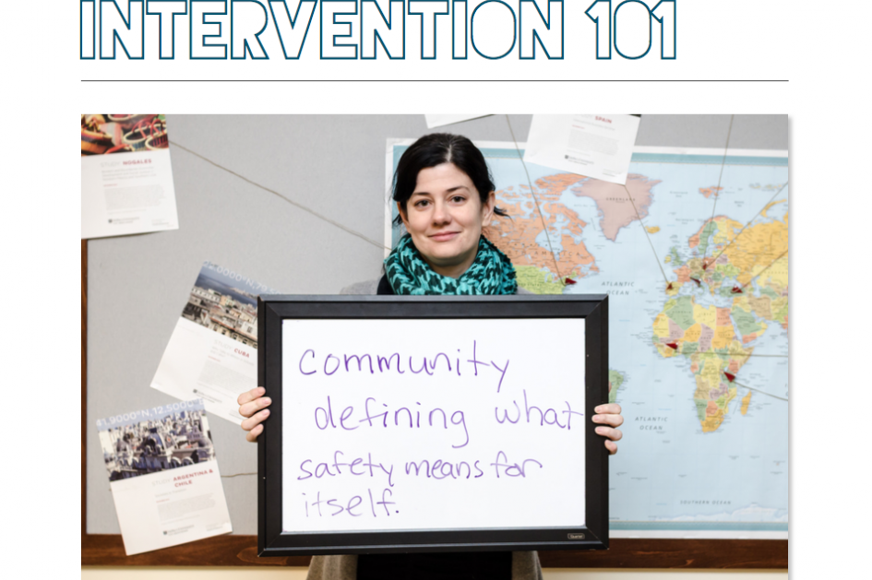

Bystander Intervention 101 (PDF)

This training guide by the People's Response Team in Chicago provides an outline for introducing participants to the dos and don'ts of bystander intervention using group discussion and role-plays.
BLOG

Standing up to anti-Asian racism

With more reports of harassment and attacks against Asians around the U.S., here are some ways you can help respond to racism and build the safe and peaceful communities we all deserve.

Get involved
TRAINING

Bystander intervention and de-escalation

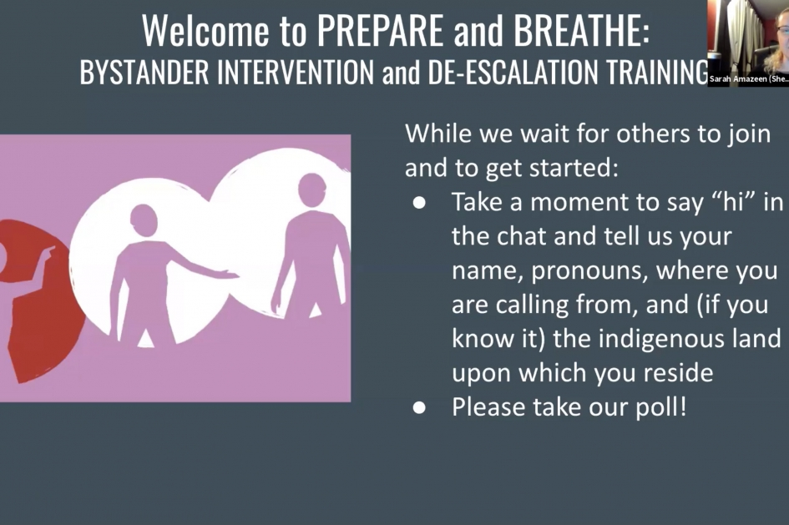
VIDEO

Webinar: Bystander Intervention and De-Escalation Training

Examples of University/Organizational Videos and articles

The following resources are from the University of Illinois website. Many organizations have a similar repository of resources on their sites.
- "Anti-Asian Racism during COVID-19" presented by Dr. David Chih, Dr. Teresa Mok, and Dr. Joycelyn Landrum-Brown- https://mediaspace.illinois.edu/media/t/1_vm818gtl

- "Our Greatest Potential- Asian American Leadership and Empowerment" presented by U.S. Diplomat and UI Alum Yuri
Kim- https://mediaspace.illinois.edu/media/t/1_kjwo9lw6

- Mental Health Experts Offer Advice for Processing Discrimination- https://www.wcia.com/news/mental-health-experts-offer-advice-for-processing-discrimination/

- Health Experts Address Rise in Attacks Against Asians in the U.S.: Racism is a public health crisis
Carle Illinois College of Medicine explores the recent discrimination and attacks, and its health impacts with David Chih, founding director of the Asian American Cultural Center at the University of Illinois Urbana-Champaign, and Teresa Mok, a licensed clinical psychologist in Urbana, Ill. - https://medicine.illinois.edu/health-experts-address-rise-in-attacks-against-asians-in-the-u-s/

- Anti-Asian Hate is Taking a Toll on Central Illinois' Asian American Community- by Christine Herman - https://illinoisnewsroom.org/anti-asian-hate-is-taking-a-toll-on-asian-american-communities-including-in-central-illinois/

- Combatting Anti-Asian Racism by Emily Boudreau
Equipping educators with restorative justice techniques to upend discrimination and stereotypes- https://www.gse.harvard.edu/news/uk/20/11/combatting-anti-asian-racism

- Editorial| America's Gross Negligence Persecutes Asian Americans- https://dailyillini.com/opinions/2021/03/25/editorial-americas-gross-negligence-persecutes-asian-americans/

- Editorial| On anti-Asian racism in CU- https://www.smilepolitely.com/opinion/on_anti_asian_racism_in_c_u/
- CU community rallies together to address the increase in anti-Asian hate-https://dailyillini.com/news/around-campus/2021/03/29/cu-community-rallies-together-to-address-the-increase-in-anti-asian-hate/

- Vigil held to remember victims of Atlanta shootings and to stop Asian hate- https://www.news-gazette.com/news/vigil-held-to-remember-victims-of-atlanta-shootings-and-to-stopasianhate/article_46cf657f-6a0a-5764-9aa1-e18f1f63f810.html

- Asian Women: The Toll of Decades of Dismissal - https://will.illinois.edu/21stshow/story/asian-women-the-toll-of-decades-of-dismissal

- Interview| Theresa Mah, Asian American Caucus -https://will.illinois.edu/21stshow/story/theresa-mah-asian-american-caucus

- The Rise of Anti-Asian Violence- https://will.illinois.edu/21stshow/story/anti-asian-violence

- WAND17 Rally for Asian American Community - https://www.wandtv.com/news/videos/rally-shows-solidarity-for-asian-american-community/video_02b21b3d-1a6d-564a-a5a9-3b316fdef667.html

- Asian American University students fear for elders after spate of racist attacks, urge others to speak to speak out: 'It's up to us as a community'- https://www.chicagotribune.com/news/ct-aapi-hate-crimes-young-asian-americans-20210402-xvy6heqblnaq5oio56pxbuvexi-story.html

- CU community rallies to #StopAsianHate- https://dailyillini.com/news/champaign-urbana/2021/04/05/cu-community-rallies-to-stopasianhate/

- AACC Director Disusses Ways to Support Asian Community- https://dailyillini.com/features/2021/04/19/aacc-director-discusses-ways-to-support-asian-community/

- Anti-Asian Violence Scares UI Community- https://dailyillini.com/features/2021/04/22/anti-asian-violence-scares-ui-community/

Examples of solidarity statements
Office of the Chancellor and Vice Chancellor for Diversity Equity & Inclusion
Office of Inclusion and Intercultural Relations (OIIR)
Dept of Asian American Studies & Dept of Gender and Women’s Studies
Center for East Asian and Pacific Studies & the Dept of East Asian Languages and Cultures
Department of History
Illinois Student Government
University of Illinois System
Champaign Chinese Magazine
City of Urbana
City of Champaign
Asian Pacific American Medical Student Association at Carle Illinois College of Medicine
Asian Law Students Association, College of Law

- Bias Assessment and Response Team- Please report all bias-motivated incidents that occur within our University community to the Bias Assessment and Response Team at bart.illinois.edu
- Resources for Champaign Urbana's Asian American and Pacific Islander Communities- https://champaignil.gov/2021/03/23/resources-for-champaign-urbanas-asian-american-and-pacific-islander-communities/
- To learn more about anti-Asian hate and to report incidents that occur anywere, visit stopaapihate.org
- Stand Against Hatred- https://www.standagainsthatred.org/
- Stop AAPI Hate- stopaapihate.org

- NYU Anti-Racism Education, Programs and Resources- https://www.nyu.edu/life/global-inclusion-and-diversity/anti-racism.html

- Seattle University- Toolkit for Anti-Asian

- Racism- https://www.seattleu.edu/diversity/resources/toolkit-for-anti-asian-racism/

- Cornell University- Anti-Racism Resources for the AAPI Community - https://asianamericanstudies.cornell.edu/anti-racism-resources-aapi-community
Asian American Day of Action- https://www.asianamericandayofaction.com/

- Smithsonian Asian Pacific American Center- http://smithsonianapa.org/stand/?fbclid=IwAR207vnFwJUdNUmrXyI03HE6FBV6truHOSpfh9ZAEeimRHe-gc_xGbhqoPA

- Learning for Justice- https://www.learningforjustice.org/magazine/how-to-respond-to-coronavirus-racism

